BLINDFOLD

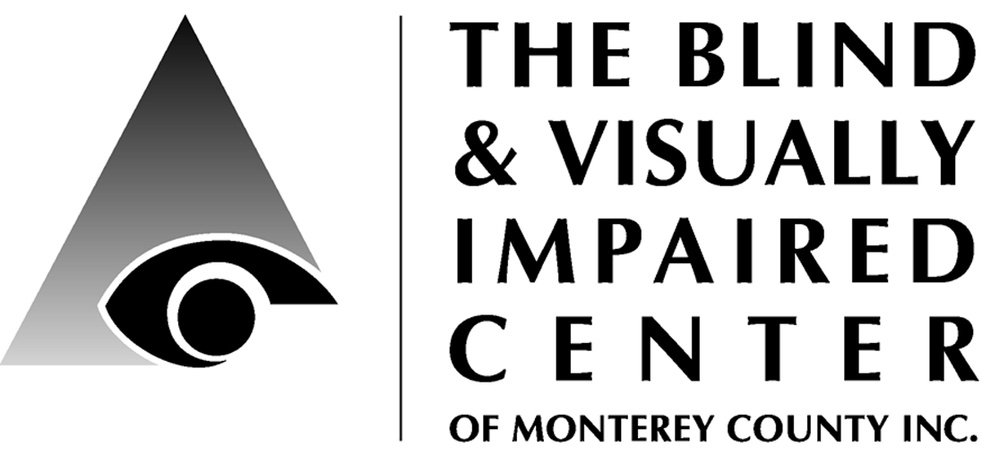

225 Laurel Avenue, Pacific Grove, CA 93950 (831) 649-3505 www.blindandlowvision.org

Spring 2017

NEWS & ANNOUNCEMENTS

Vision Care & Assistive Technology Day
The Marjorie R. McNeely Low Vision Clinic is pleased to be hosting Vision Care & Assistive Technology Day on June 17th.

Two low vision specialists will talk about vision loss, and vendors of various assistive technologies will have items on display.

This event is co-sponsored by the Meals on Wheels of the Monterey Peninsula and the Sally Griffin Center.

Date: Saturday, June 17
Time: 10:30am – 3:30pm
Location: Sally Griffin Center
700 Jewel Ave
Pacific Grove, CA
Cost: FREE but donations requested

RSVP: Space is limited to 75.
Diana at 831-649-3505
or diana@blindandlowvision.org

Admission is FREE but donations are requested to defray costs, which include a free bag lunch.

Reservations are required by noon on Monday, June 12th.

Volunteer Opportunities
We are seeking volunteers to staff the front desk, answer the phone and greet visitors: 9:00am-1:30pm Tuesday, Thursday or Friday.

Tuesday Ceramic Art Class Volunteers:
Tuesdays from 11:00am – 2:00pm with lunch or 12:00noon – 2:00pm without lunch.

Peer Support Groups
English:
- 1st & 3rd Tuesday from 10:00-11:30 a.m. at 225 Laurel Ave, Pacific Grove
- 2nd & 4th Thursday from 9:00-10:30 a.m. at St. Ansgar’s Lutheran Church, 72 E. San Joaquin St., Salinas
Spanish:
- 1st & 3rd Thursday from 9:00-10:30 a.m. at St. Ansgar’s Lutheran Church

Please contact Karen for more information: 831-649-3505 x104.

Apple Store Discover Accessibility Classes
The BVIC is pleased to collaborate with the Apple Store, Del Monte Shopping Center to provide "Discover Accessibility" workshops on the accessibility features of the Mac and iPhone/iPad. To sign-up, visit their website: https://concierge.apple.com/workshops/R305/en_US/

President’s Message
Dr. Ken Hunter
A wise man once said that the only constant in life was change. This seemingly contradictory statement certainly applies to the Blind and Visually Impaired Center (BVIC) of Monterey County. In the past two years, the BVIC has seen a major change in its staff, its Board of Directors, and in its resolve.

When I first visited the BVIC, Jackie Johnson was the Intake Coordinator. She was the person who introduced me to the BVIC’s programs and services. She also made the important referral to the VA Palo Alto’s Western Blind Rehabilitation Center in Menlo Park. Jackie signed me up for the Braille and Talking Book Library in Sacramento. She also referred me to the other staff at the BVIC. I met Renna Weaver, the Orientation and Mobility instructor. She gave me my first white cane and taught me how to use it in my community. She also paid a visit to my home where she oriented me to my furniture and appliances. The next person I met was Dr. Moonset Yu, the Low Vision coordinator. She helped me with various magnifiers and arranged a Low Vision Clinic examination with Dr. Andrew Wodecki. Dr. Yu’s and Dr. Wodecki’s expertise was invaluable.

Through my association with the BVIC, I became a member of the Board of Directors working closely with Jeanne Cordero, the Executive Director of the BVIC. Joining the support group under the tutelage of Ron Kihara and Diane Davenport proved to be immensely satisfying. But a change was in the works. In quick succession Jackie, Jeanne, Renna, and Moonset all retired.

This change was a period of great transition. Diana Trapani came on as our new Executive Director. Under her leadership, the BVIC was able to recruit Karen Levin, an Independent Living Skills coordinator as well as an instructor in braille. Karen is also fluent in Spanish and can complement the BVIC’s presence in the Salinas Valley. Additionally, Diana was able to bring Jenny Swad, a technology and low vision coordinator on board. Finally, with Dr. Wodecki’s departure, Diana was able to hire Dr. Katie Wendt as our new Low Vision Clinic optometrist. Diana also brought in two part-time Orientation and Mobility contractors to serve the needs of our clients. To say that this effort was Herculean is an understatement.

Staffing was not the only change at the BVIC. The Board of Directors was also undergoing some growing pains. Longtime members such as David Lloyd, Sonja Jackson, and Ron Kihara all stepped down. And sadly, Shirley Doolittle passed away. In their wake, new board members such as Becky Stewart, Celia Barberena, and Marty Lipp have joined the team. Long term board members such as Russ Hatch and Tom Gardner have provided stability.

The Board continues to meet quarterly, as well as once a year for its annual meeting. With this change in leadership has come a new vision for the BVIC. Strategic planning, fund development coordination, marketing plans, computerization, and a revision of our mission statement have all contributed to a new sense of excitement and accomplishment at the BVIC.

Another wise man once said that the more things change, the more they stay the same. This adage certainly applies to the BVIC. Despite our obvious changes in personnel and infrastructure, we are still the same organization that serves the needs of our visually-impaired here in Monterey County. I encourage each of you to drop by the BVIC and see our new look. You’ll be surprised at all the new changes and comforted by the recognition that we are still the same.

Executive Director
Diana Trapani
Diana Trapani, Executive Director
AFB Leadership Conference
March 2-4, I attended the American Foundation for the Blind (AFB) Leadership Conference in Crystal City VA. It proved informative and educational on many fronts. First, it was my first time being in a large crowd of mostly blind or visually impaired people. This made me mindful to slow down, pay closer attention to everyone around me, and aid if anyone seemed to be looking for something, such as the registration desk or a seminar room.

Each morning of the conference began with a general session speaker, each inspiring in different ways. One speaker was blind para-athlete, Patricia Walsh.

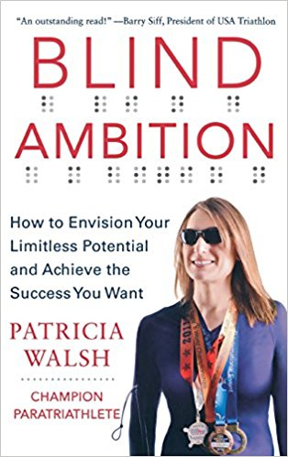
She is a high-level software designer, motivational speaker, Olympic athlete and a two-time Ironman competitor. She recently published a book: “Blind Ambition: How to Envision Your Limitless Potential and Achieve the Success You Want”. I purchased both an audio and print version for our lending library. Please let me know if you would like to borrow either version.

The conference offered a variety of educational sessions. I attended sessions about the Older Individuals with Blindness (OIB) program, nonprofit boards, collaborating with senior providers, funding and the Paralympics. I learned that many of the other centers face the same issues we do such as funding and meeting needs in rural areas. These and other issues were discussed in several of the sessions.

In 2015 and 2016, AFB gathered information from service providers and older Americans with vision loss in response to the White House Conference on Aging. From this they have launched a renewed National Agenda on Aging and Vision Loss. Over the past many months, more than 200 people have engaged in discussing and organizing around four priority goals: 1) funding for services; 2) the availability and quality of professional services; 3) collaboration across systems; and 4) funding for low vision devices. To learn more or become involved contact Sarah Malaier: SMalaier@afb.net. Current concerns include the federal budget and a shortage of trained blindness professionals.

I had the opportunity to talk with a representative from Mississippi State University. They received a multi-year grant to create and run the National Research & Training Center on Blindness & Low Vision. They conduct research, provide training, and network with service providers. They offer some free services, on-line classes and information. Be sure to visit their website: http://www.blind.msstate.edu/ and see what may be helpful to you.

Since the DCF grant funds, which is paying for attendance at conferences, is focused on assistive technologies (AT), I visited all the vendor tables and attended the AT sessions. One device displayed is the U.S. currency reader, which anyone registered with the Braille and Talking Book Library can request for free. The user simply inserts the edge of a paper dollar bill into the device and the audio plays the amount. We have application forms in English and Spanish, as well as a sample for demonstration and training in using it. Applications can also be downloaded on their website: https://www.moneyfactory.gov/uscurrencyreaderform.html
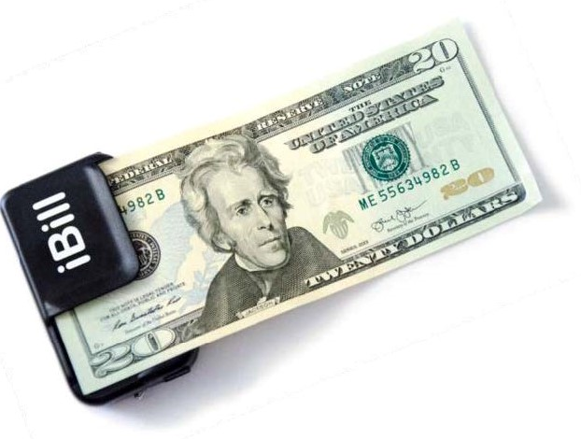
Another money reader is a free iPhone app called Eyenote. It scans U.S. currency and announces its value back to the user. The app can be downloaded for free from the Apple App Store.

I talked with a trainer from the 1 Touch Self Defense Project who offered to visit us and provide an introduction to their program. Stephen and Joseph visited our Tuesday peer support group on March 21st. 1 Touch Project is a comprehensive self-defense program designed specifically for people who are blind or visually impaired.

The program teaches hands-on self-defense techniques for dealing with bullying, aggressive behavior and assaults. Stephen discussed the perceived notion that visually impaired people are vulnerable. Then he explained and demonstrated some basic self-defense techniques and ways to convey awareness. 1 Touch provides workshops and coaching certifications courses. To learn more, visit their website: http://www.1touchproject.com.

In my down time, I used the local metro system to cross the Potomac River and visit a few of the museums at the National Mall. Although, we experienced wind and cold weather in the 30’s, the week before the conference, the weather was in the 70’s and many of the trees, bushes and flowers were blooming. This made for scenic strolling from museum to museum.

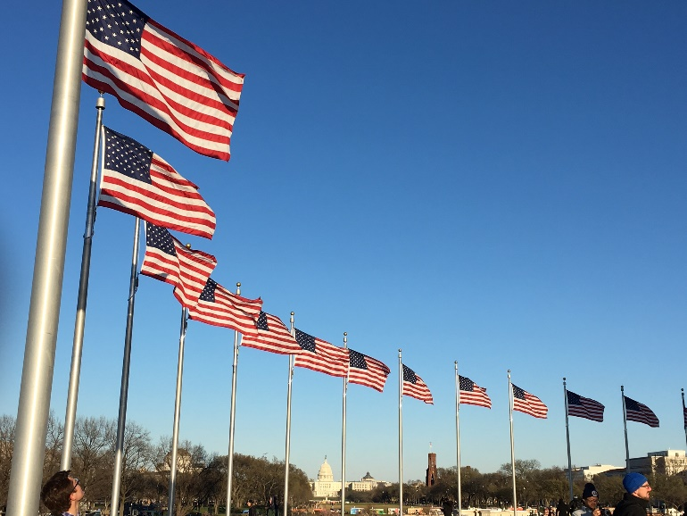
The wind was strong enough to call Washington Monument flags to full attention.

During the 1960’s my dad was an electrical engineer at NASA. He started with the GEMINI projects and worked through Apollo XIII. As a child, life revolved around the space program, as just about every dad in our neighborhood worked at NASA. Neighbors would gather together to watch the televised missions on our old black and white television and marvel that we could see and hear the astronauts from the moon!
I thoroughly enjoyed visiting the space program exhibits in the National Air and Space Museum. It reminded me of the NASA company picnics, Houston facility open houses, and the many astronauts I had chance to meet, but was too young to appreciate the magnificence of their accomplishments.

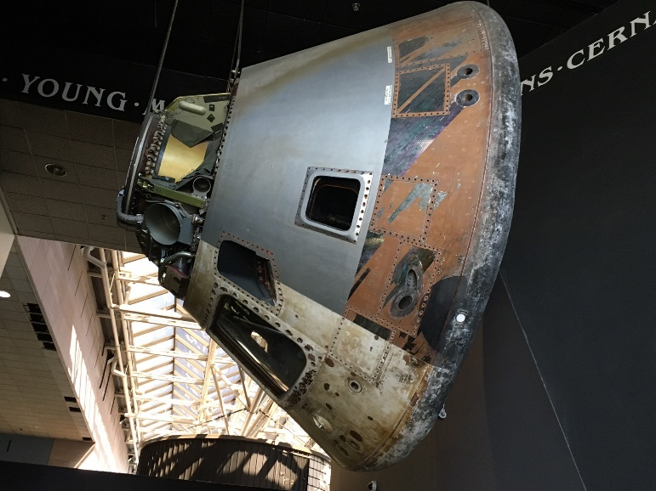Suspended from the ceiling is one of
the capsules used for re-entry.

Under our hotel was access to the metro and a mini-mall with several restaurants. I found the very fun “King Street Blues” and enjoyed pulled pork, ribs, draft beer and good blues music. Every wall, corner and odd space was painted or filled with a lively scene or blues characters.

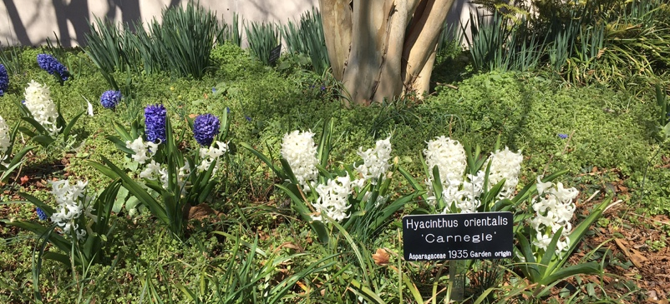
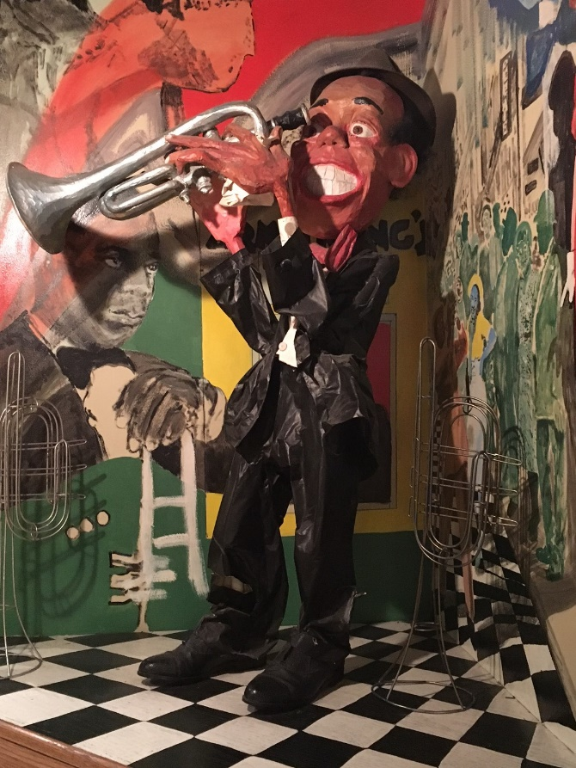

Overall, the AFB conference was well worth the time for professional development, as well as personal enjoyment. Disability Communications Fund supports technology and programs that serve the communication of Californian’s with disabilities. Their 2017 funding focus is “training the next generation of AT and AAC experts”. Without their grant funding, Sam, Jenny, Karen, Katie and I wouldn’t be able to attend these informative conferences and share what we learn with you. Thank you DCF!

Vision Rehabilitation Therapy
Karen Levin, VRT
Phones for Low Vision and Blind Seniors
In early March, I attended the CSUN conference in San Diego. CSUN is an annual assistive technology conference providing a wide array of educational sessions and vendor exhibits. I attended an all-day training called “Intro to Assistive Technology”. This class provided an overview of a wide array of devices available for use with children and adults with a variety of visual, physical or hearing and communication impairments.

I attend several other sessions which talked about ZoomText Fusion, From Low Vison to No Vision, Excel Tips and Tricks, What’s New in Jaws 18 and Magic 14, and Google Apps Accessibility. One particularly interesting session I attended provided information and suggestions about cell phones for seniors living with no or low vision. I thought the information I learned may be informative to you.

Living in a rural or urban area often plays a part in deciding which service provider to select. It is recommended to research more than cost and minutes. Coverage, dependability and compatibility with your phone type (apple or android) are things to consider.

When deciding to purchase a phone, it can be helpful to keep in mind your needs, the ease of use, Seri (voice) access, voice dialing, and the dial buttons. Are the dial buttons easy to see and/or feel, are they tactile or not, do they have large enough fonts for you to easily read, is there contrast in the color of the number on the button?

What type of operating system does the phone use and what are your needs? Some phones require low vision users to purchase third party software in order to be accessible, and some operating systems are completely inaccessible.
What types of accessible features does the phone offer? How easy is it to learn to use these features? Does the store offer free classes in a location and at a time that you can attend?

Some of the accessible phones reviewed in the session include these: Snapfon, Emporia, Doro phones, Jitterbug, LG Terra, Convoy 4, Samsung Gusto 3, Alcatel flip phone, and iPhone.

Pricing also plays a factor, expecially for seniors on a fixed income. Some phones are reasonable however, they may not have the features you are seeking. Other phones are more pricey but have more accessible features. Initial purchase price, monthly minutes, and monthly fees are also factors to consider when selecting a cell phone. In the end, make sure that it has the accessible features to assist with your personal needs and meets your financial budget.

If you have questions – call me!

Low Vision Clinic
Jenny Swad, CLVT/COMS
Task lighting: An essential need for those with low vision.
Did you know that as we age, we need two times more light in order to perform certain tasks more comfortably? When we add low vision to the equation, it becomes imperative that we use the correct lighting in our living space. Two very important considerations are the type of bulb that suits the task at hand and the placement of the light. Fortunately, there are now many choices as to what types of lights we use in our homes that will allow us to continue enjoying reading, writing and various hobbies.

Though there are different types of lighting in a home, when I do a home lighting assessment, my goal is to improve task lighting. First, consider what type of lamp and bulbs you are currently using to go about your day - for example, sitting in the living room to read or do crossword puzzles, sitting at the kitchen table to look at medications or to see the food on your plate, or spending time in your office to read documents, write checks, and even sew. Are you using a dark lamp shade that “eats” all the projected light from the bulb? Is your lamp too far away from your task?

Let’s address the types of bulbs that are available in hardware stores – warm (yellow light), cool (blue light), and natural spectrum (white light). So, while the type of lamp you use is important, the bulb is equally important. It is no longer just about wattage.

Now, depending on the task at hand, will a floor lamp or table lamp be the best option for your room? Put the lamp on the side of your best eye; if it is a floor lamp, place it slightly behind you and over your shoulder. In order to get the best possible result, work with someone to make sure that there are no shadows on the material you are trying to view.

If you would like an in-home task lighting assessment, I currently have a table lamp that has all three bulb colors and a brightness control that I can bring to you. Feel free to call me if you would like to set-up a task lighting assessment in your living space. Once you know the best light for your eye condition, you can more confidently purchase what you need.

I conclude by going back to the subject of overhead room lighting. It is best if you keep all your rooms at the same illumination level so that your eyes don’t have to go through the adjustment of going from a dark room to a bright room and visa-versa. Ever so important is that you have a light on at night to get from your bedroom to the bathroom and back again. Also, consider plugging in a timer for certain lights or using automatic censored lights to decrease your risk of falling due to insufficient lighting.

If you want to schedule a home lighting assessment, please call me.

Rehabilitation Assistant
Samantha Kelley
Video Chat & Video Photo Apps
Hello Everyone! As you all know, technology is changing on the daily, making it harder and harder to keep up with the latest and greatest gadgets and phone apps. Recently, I discovered two different smart phone apps that might be of interest to you. Both aim to assist the blind and visually impaired with daily tasks of all sorts. Though each app operates in a different manner, they strive for the same goal – helping the user solve a problem independently and on the spot. Both are free and are compatible with smartphones and tablets.

Be My Eyes – The Be My Eyes App connects a user to a volunteer through a live video stream. Say for example you have a basket of thread in front of you and you need to find the blue one. You would open the Be My Eyes app on your phone and it would automatically connect you with an available volunteer who can see what you are seeing through the camera on your smart phone. They can direct you where to point the camera and you can ask them whatever it is that you need to do. Where is the blue thread? The volunteer can guide you through the basket until you find it together. It’s as easy as that! What’s more is, for the almost 33,000 blind and visually impaired people using the app, there are over 457,000 volunteers. So, say for example it’s 3:00 a.m. and you are on a late-night sewing bender (hey, it happens!). Be My Eyes can connect you with someone in a different time zone, somewhere in the world, who is awake and can assist. Visit their website: http://bemyeyes.com/ .

BeSpecular – BeSpecular is another app with a different method of function. With this app, you take of photograph of the item/question in play, record a voice memo or write a text with your question, and send it out. BeSpecular uses an algorithm to connect you to the right people, considering age and physical location. For example, if you are in the kitchen and are unsure of whether you are about to cut into a red onion or a white onion, you can photograph said onion, write or audio record your question, and send it off. Typically, you will have a response from a volunteer within 30 seconds. One example showed a visually impaired woman preparing for a job interview. She was unsure of whether her outfit was suitable, so she snapped a photo with her phone, recorded “Will you tell me if this outfit works for my job interview?”, and sent it off. Within seconds, a volunteer received the inquiry and sent her a message back saying that the outfit was lovely and wished her good luck. Visit their website: https://www.bespecular.com/ .

In closing, each of these apps pair users with eager and willing sighted volunteers who can help with basic, everyday tasks. It allows an individual to ask for help in real time instead of having to wait for someone to show up or feel like you are bothering a friend or family member. This way, it’s anonymous, on the spot, and you are asking assistance from someone you know genuinely wants to help. If you would like more information or need help finding or downloading these apps, don’t hesitate to contact me.

Retinitis Pigmentosa Research
Dr. Katie Wendt, OD
Recently I attended a talk at UC Berkeley’s School of Optometry given by Dr. Tim Schoen of The Foundation Fighting Blindness (FFB). FFB is the world’s leading private funder of research for cures for inherited retinal diseases (IRDs). Examples of IRDs include Usher, Stargardt, Best and Retinitis Pigmentosa. Because these diseases are all caused by one gene defects (e.g. deletion, duplication or insertion) they are also known as the “orphan” retinal diseases.
Dr. Schoen relayed that the FFB and Blueprint Genetics are collaborating a pilot project to advance the clinical trials process for those with IRDs by working to grow the data in a Foundation-supported patient registry. IRD-affected patients or family members may register in the international registry at www.MyRetinaTracker.org. Some patients will be eligible for free genetic testing.
What is the value in genetic testing for those with IRDs? Genetic testing yields the most accurate diagnosis and can predict the disease’s severity as there are different types (levels) of some of these diseases. Additionally, genetic testing confirms inheritance patterns and is required if one is seeking any type of gene therapy in the future.

Research is leading to exciting possibilities in the field of gene therapy. Gene therapy works by taking the specific disease replacement (no defect) gene and incorporating it into virus. In RP studies, the virus is injected into eye and through transcription allows for non-defective proteins to be assembled.

There are many more discoveries awaiting in the field of gene therapy. The Foundation Fighting Blindness website (www.blindness.org) has a News & Research section. You can read more about the latest in vision research there.

2016 Annual Report Data
This past year was one of changes and setting the stage for growth of the BVIC. With change we usually experience challenges, and that was the case here. Change started with the retirement of four long-time staff. This brought challenges of gaps in service and the need for new staff in a competitive field due to the low numbers of qualified professionals. We were very fortunate to find three outstanding program staff in Jenny, Karen and Katie!

With new staff comes different skill sets, experience and points of view. This leads to changes in how things are done, as each new employee brings their own style and viewpoints on work flow, efficiency, documentation, and the like. Over the past few months we have been learning to work together and determining where to make changes for the better.

Even with the breaks in service, during 2016 we served a total of 323 unduplicated clients with the following statistics:

Primary Eye Condition 2016
56% = AMD
19% = Other (stroke, birth defect, optic neuropathy, corneal edema, tumor, etc.)
7% = Diabetic Retinopathy
7% = Unknown
6% = Glaucoma
4% = Retinitis Pigmentosa
1% = Cataracts

Gender 2016 | Race 2016
67% Female | 73% White
33% Male | 15% Hispanic
 | 12% Asian
 | 11% Black
 | 16% Other/Unknown
Region of Residence 2016
59% = Peninsula
31% = Salinas Valley
9% = Other/Unknown

Age 2016
3.4% = Teens/20’s
1.2% = 30’s
2.8% = 40’s
6.5% = 50’s
11.8% = 60’s
13.3% = 70’s
31% = 80’s
22.3% = 90’s
2.5% = 100+
5.3% Unknown

Typically, clients utilize more than one service offered at BVIC. This data represents the services utilization by percentage of total 2016 clients served.

Service Area 2016
57% = Low Vision Clinic Services
37.2% = Low Vision Clinic with eye doctor
51% = Intake/Referral/Support
61.3% = Assistive Technology/Device Sale
16.7% = Other Support Services
30.3% = Vision Rehabilitation Therapy
13.9% = Orientation & Mobility Services
2.2% = Ceramic Art Class
8% = Tuesday Socialization & Lunch
8.7% = Tuesday Support Group
1.9% = Thursday English Support Group
.6% = Thursday Spanish Support Group

We distribute information about our vision loss and our services throughout the county. In 2016 more than 2348 people indirectly received services through our outreach efforts.

Community Outreach is a growing service offered by BVIC. We provide basic low vision training to other service providers, attend health fairs and/or present informational sessions at senior living communities and in the wider community.

If you would like us to visit your living community or attend your community event, please contact Sam at 649-3505.

We extend our heartfelt thanks to everyone who supported us in 2016!
If we misspelled your name or missed listing you, please contact the office.

2016 Donors
Acosta, Margarite
Alexander, Maria
Altrusa International of the
Monterey Peninsula
Ames, David
Amundsen, Elizabeth
Anable, Leonard
Anonymous
Angelie, Jeff & Cindy
Anloff, Patricia
Anna J. Davis Trust
Arnot, Dene
Attie, Mariana
Axe, John
Axton, Rosemarie
Ayres, Tony
Back Porch Fabric
Baer, George & Kristina
Bailey, Rosylan
Baker, Suzi
Bales, Kathy
Banks, Dave & Wendy
Barnet Segal Charitable Trust
Barnhart, Lucille
Bartels, Franzel
Bellini Foundation
Bennett, Barbara
Bergam, Roger
Benz, Chris
Bevans, Ingermarie
Blel, Victoria
Bloch, R. Stephen
Blom, Brenda
Bloxom, Anne
Bollin, Dick & Pat
Bosworth, Celia
Braudrick, Hazel
Britton, Robert
Brott, Dale
Brown, Charles
Brown, Elizabeth Plaxton
Brown, Mercedes
Brown, Rosemary
Browning, Paula
Bucquet, Barbara
Budlong, Edwin & Barberena, Celia
Bugarin, Eva
Bullock, Lyndy
Burja, Steve & Karen
Burke, Vita
Calhoon, Theodore & Dana
Cardoza, Joan
Carmel Chamber of Commerce
Carmel Host Lions Club
Carmel Mission Trail Lions Club
Carmel Valley Rotary Club
Carmel Women’s Club
Carns, Victoria & Michael
Chamberlain, Barbara & David
Chavez, Agueda & Rosa
Chiappe, Elio & Gerry
Chow Hoon, Pauline
Christin, Mary Margaret
Church Women United of the
Monterey Peninsula
Cislini Fund of the Community Foundation for Monterey County
Cocker, Enid
Colburn, Mary
Colvin, Gloria
Community Foundation for
Monterey County
Coniglio, Carla
Conlow, M Robin
Covarrubias, Fernando
Cozzens, Kathlene
Craft, Nick & Becky
Craig, Carolyn & Geoff
Crittenden, Beth
Cruz, Celeste
Csikesz, Bela
Cutino, Bert & Bella
Dalkey, Sharon Lee
David, Beverly
Davidson, Erik & Lori
Diaz, Herminia
Davis, Paul
Diaz, Herminia
Dick, John
Disability Communications Fund
Doolittle, William & Nancy
Dowden, Iris
Dunn, Virginia & Richard
Disek, R.K.
Dwight, Sharon
Earp, Dorothy Palmer
Enea, Frank
Episcopal Senior Communities
Erik & Lori Davidson Fund
Fandango Restaurant
Farrant, Catherine
Fehl, Cecile
Fehring Holbrook, JoAnn
Ferguson, Cheryl
Fergusson, Carroll
Ferrante, Barbara
First Baptist Church
of Pacific Grove
First Presbyterian Church
Fiske, Ernest
Fitton, Cyrus & Jean
Flaherty, Helen
Flicker, Perry
Ford, David & Bautch, Meri
Forman, Sandra
Forrest, Julie
Franke, Rick & Kit
Frasca, Joyce
Freedom Lions Club
Freeman, Donald
Friends Forever
Fritz, Roxan
Fugate, Travis
Gamble, Barbara
Garcia, Aurelie
Gardner, Thomas & Sylvia
Gaver, Donald
Geary, Patti & George
Gehringer, Helen
Gilkey, Cliff & Peggy
Glazier, Carol
Gordon, Dorothy
Green, Arnold
Gregory, Alan & Wendy
Gross, Sabreh
Gryp, Janice
Gunderson, Gary & Tab
Gurtin, River and Diana
Haas, Doris
Hageman, George
Hageman, Jonathan
Hagey, Dolores
Haidich, Josephine
Haig, Candy
Hale, John
Hanson, Janet
Harden Foundation
Harris, Dirk & Karen
Hatch, Russ & Jo-Ann
Hattori Vision Optometry
Heinz, Otto
Henson, Randy
Herschede, Lois
Hirsh, Jennifer
Holine, Virginia
Hollister, Ted
Holmlund, Helen
Hough, Sonia
Howitt, Deborah
Hunter, Ken
Hurd, Sylvia
Hutchins, Charles
Irwin, Martin
Jackson, William & Sonja
Jefferson, John & Lucille
Jefferson, Veronica
Johansen, Holger "Bud"
Johnson, Bob
Johnson, Lila
Johnson, Marjorie
Johnson, Michaele
Johnstone, Elizabeth
Jurkovich, Sandra
Kadiev, George & Nina
Kalber, Audrey
Kane, Steve
Karanis, Joshua
Kearney, Annette
Keip, Nadia
Keland, Harold
Keleher, Norma
Keyser, Virginia
Khamzina, Guldana
Kihara, Ron & Ann
Kilty, Margaret
Kim, Grace
Korper, Tom & Marta
Kraus, John
Labbe,Theona
Laiolo, Elinor
Langstroth, Elizabeth
Larez, Maria
LaVaun, Ron
Laws, David & Jean
Leadingham, Marsha
Leavenworth, Ted & Mimi
Ledin, Lisa
Legard, Robert & Kimberly
LeValley, Wallace & MaryKay
Levin, Karin
Lew, Lawrence
Lincoln, Sarah
Lions Building for the Blind
Lipp, Martin & Natividad
Little, Kevin & Miriam
Livingston, Barbara Timmins
Lloyd, David & Dona
Loop, Mel
Lorenz, Roy
Lorenzen, Julie
Lotz, Margaret & John
Lovell, Jean
Lucas Foundation
Lundy, Jane
Lyon, Willis
Lyon, Yvonne
MacGlashan, Charles
Maraccini, Jim & Diane
Marina Grange #518
Marjorie McNeely Fund for the
Blind or Illiterate of The
Community Foundation for
Monterey County
Maroot, Janice
Marquez, Janis
Martin, Elaine
Masatani, Marilyn
Matsuyama, Mrs. Eva
Matsuyama, Ruth Aiko
McBee, Gloria
McGarity, Lee
McMahan, Mick & Nicki
Mehl, Geneva
Merrell, Esther
Miguel, Heide
Mildred Hitchcock Huff
Charitable Trust
Mission Trail Lions Club of Carmel
Moe, Alice
Monterey Peninsula Foundation
Monterey Peninsula Host Lions
Monterey Peninsula Volunteer
Services
Monterey Symphony
Morgan, Elisha
Moritz, Jean
Morris, Miranda
Musavi, Sadri
Nagata, George & Joanne
Nicholson, R.L. & Katherine
Nicolai, Adolph
Nielsen, Gary & Deborah
Nohr, Maria
Noseworthy, Michelle
O'Connor, Paula
Old Capitol Lions
Oliver, Tom & Margaret
Ozenne, Helga
Padin, Cheri
Palmer Earp, Dorothy
Parenti, Margaret
Parrott, Edward & Eva
Parsons, Julie
Pastor, Francis
Paul, Betty
Pearse, John & Vicki
Peasley, Barbara
Pebble Beach Company
Peel, Alan
Pepperdene, Rose
Perez, Lilia P
Perocchi, Nanci
Pesce, Mr. & Mrs. Thomas
Phillips, Vivian
Poland, James
Pommerich, Mary
Potter, Albertine
Quaglia, Johnny
Quamen, Ann
Radunich, Margaret Anderson
Rayne, Gerda
Redstone, Charlotte
Reid, Dorothy
Rhodes, Dan & Robbie
Riddell, Lorraine
Roberts, Sori
Rosen, Lee & Shirley
Rubin, Steven
Ruhl, Pauline
Ruiz, Kathleen
Russell, Genni
Sabih, David
Salinas Host Lions
Salinas, Jennie
Sanders, Karen
Sargisson, Stuart & Lisa
Saurez, Jorge & Becky
SaveMart
Sawyer, Sally
Schoenwisner, Mona
Schure, Cam
Schwoerke, Karin
Selfridge, Nancy
Shaffi, Frances
Sherman, Mary
Shimizu, Ronald
Shipley, Margaret
Silverman, Marv
Smith, Clara
Sparling, Shirley
Spector, Atkins & Fran
Springer, Eleanor
Springer, Elizabeth
Springer-Ochs, Nancy
Stafford, Doug & Karen
Stallings, Berry Jean
Stengel, Naidene
Stewart, Robert & Becky
Storm, Steve & Roxanne
Stout, Candi
Suarez, Jorge
Suter, Jean
Suyematsu, Jo Ann
Tally, Doug
Teixeira, Sylvia
Thomas, Barbara
Thomas, Barbara & Douglas
Thompson, Stella
Toro Place Café
Tragethon, Jan
Trapani, Diana & John
Trinidad, Bernadette
Trykowski, Lonnie & Eppler, Jerry
Tucker, Philip
Uchida, Kiyoko
Valencia, Jan & Cath
VanArsdol, Maurice
Van Horn, Dana
Vaughn, Marie & Roger
Wagner, Bruce & Juana
Waller, Lila
Warde, Kenny
Walters, Lila
Wasson, Richard
Watts, David and Michaelin
Weaver, Rena & John
Weber, Ann
Weeth, Lois
Weismann, Richard & Joyce
Welsh, Michelle
Wendt, Katie
Westcott, Bud & Jean
Williams, Jeanne
Williams, Roberta
Williamson, Donald
Wills, Judy & Tom
Wilson, Andrew & Ardith
Wilson, Janet
Wilson, Julia
Wilson, Ken & Sharon
Wilson Boast, Maggy
Wright, Carla
Wylie, Judith
Yellow Brick Road Benefit Shop
Yost, David & Terri
Young, G E
Ziegenbei, Constance

2016 MC GIVES DONORS
A and R Plumbing
Anonymous
Thomas, Barbara
Cutino, Bert & Bella
Stalling, Betty Jean
Johnson, Bob
Tendler-Valencia, Cath &
Valencia, Jan
Bosworth, Celia
Warde, Christine & Kenny
Van Horn, Dana
Watts, David & Michaelin
Ford, David & Bautch, Meri
Laws, David & Jean
Sabih, David S.
Howitt, Deborah
Case-Gurtin, Diana & Gurtin, River
Creasey, Diane & Robert
Parrott, Eva & Edward
Spector Atkins, Fran &
Atkins, James
Pastor, Francis
Russell, Genni & Roy Ronald
Lovell, Jean
Suyematsu, Jo Ann
Meyers, Jonina
Karanis, Joshua
Wills, Judith
Sanders, Karen
Harris, Karen & Dirk
Hunter, Ken
Baer, Kristina & George
Rosen, Lee & Shirley
Herschede, Lois Joan
Trykowski, Lonni & Eppler, Jerry
Boast, Maggy Wilson
Marina Motorsports, Inc
Lipp, Marty & Natividad
Pommerich, Mary
Mogensen, Mellynee
McMahan, Nicki & Mick
Nicholson, R.L. & Katharine
Dusek, R.K.
Franke, Rick & Hunter-Franke, Kit
Hatch, Russ & Jo-Ann
Sawyer, Sally
Bergam, Sandra & Roger
Jurkovich, Sandra
Dwight, Sharon
Thompson, Stella & Frank
Baker, Suzi
Gardner, Tom & Sylvia
Pearse, Vicki & John
Gregory, Wendy & Alan

2016 Corporate & Business DONORS
A and R Plumbing
Adventures by the Sea
Amazon Smile
Anonymous
Back Porch Fabric
Bodywork & Therapeutic Massage
Café Fina
California Pizza Kitchen
Cannery Row Company
Carmel Chamber of Commerce
Carmel Host Lions Club
Carmel Mission Trail Lions Club
Carmel Valley Rotary Club
Carmel Women’s Club
Chatterbaux Children’s Shoppe
D'Arrigo Brothers Company
Disability Communications Fund
Domenico’s on the Wharf
Dority Roofing & Solar
El Estero Car Wash
Electronic Scrip Rebate
Events by Classic Catering
Fandango Restaurant
Fish Hopper
Goodshop
Hattori Vision Optometry
Holly’s Lighthouse Café
Il Vecchio
Jeffrey’s Grill & Catering
Katy’s Place
Kris Kringle of Carmel
Linda's Hair Styles
Marina Motorsports
Monterey Bay Analytical Services
Monterey Bay Whale Watch
Monterey Institute of Touch
Monterey Peninsula Foundation
Monterey Peninsula Host Lions
Monterey Peninsula
Volunteer Services
Monterey Scottish Games
& Celtic Festival
Monterey Symphony
Network for Good
North Fremont Business District
Pacific Grove Cleaners
Pacific Grove Hardware
Pacific Thai Cuisine
Paul Davis Partnership
Pavel’s Backerei
Pay Pal Giving Fund
Pebble Beach Company
Peninsula Gem & Jewelry Supply
Peppers Mexicali Café
Portola Hotel & Spa at Monterey Bay
Rosine’s Restaurant
SaveMart
TMD Creative
TOBI Cares
Tom's Monterey Auto Repair
Toro Place Café
Victorian Corner
Winchester Mystery House

The BVIC thanks everyone for their support. If we misspelled your name or missed listing you, please contact the office.

BVIC extends a very special acknowledgement to Nick Pasculli and the TMD Creative team for their superior support, guidance, work and in-kind donations! We couldn’t have accomplished it all without your talents and efforts.
We are off to a great start in 2017 and thank everyone for their support!
Donors: January 1 –
March 31, 2017.
Amazon Smile
Anonymous
Axe, john
Bloxom, Anne
Bohn, Margaret
Britton, Robert
Budlong, Edwin & Barberena, Celia
Cannon, Thomas
Capital One Bank
Cardoza, Joan
Chamberlain, B
Chavez, Agueda
Chiappe, Elio
Church Women United
Cocker, Enid
Cocklin, Norma
Covarrubias, Fernando
Cruz, Celeste
David, Beverly
Dorman, Ann
E-Scrip
First Baptist Church
Fiske, Ernest
Freedom Lions Club
Gasperson, Jayne
Gehringer, Helen
Glazier, Carol
Gross, Sabreh
Gunderson, Gary
Hanson, Janet
Hattori Vision Optometry
Hunter, Ken
Jackson, Sonja
James, Paul & Ellen
Jamieson, Elizabeth
Johansen, Bud
Johnson, Bob
Johnson, Joan & Harry
Kane, Steve
Kihara, Ron
Kim, Grace
Kissel, Helen
Larez, Maria
Loop, Mel
Lundy, Jane
Lyon, Willis
Mamat, Jane
Marina Lions Club
Moe, Alice
Monterey Peninsula Foundation
Musavi, Sadri
Network For Good
Nicolai, Adolph
Old Capitol Lions
Ozenne, Helga
Pacific Thai Cuisine
Peel, Elinor & Alan
Pepperdene, Rose
Prunedale Lions Club
Ruhl, Pauline
Schoenwisner, Mona
Schure, Cam
Silicon Valley Community
Foundation
Smith, Clara
Squires, Walter
Stengel, Naidene
Streeter, Thomas
Swerrie, Allyne
Tackett, Vicki & William
Thompson, Stella
Torrero, George
Uchida, Kiyoko
United Way of Central Maryland
Wagner, Rosa
Wenzel, Margaret
Wills, Judy
Wodecki, Andrew
Ziegenbein, Constance

Kathy Henson Legacy Society
By including BVIC in your estate plans, you can help others in the coming decades transcend the loss the sight with a legacy gift.

Sample bequest language: “I give, devise and bequeath to The Blind & Visually Impaired Center of Monterey County, Inc., a nonprofit corporation of the State of California, located at 225 Laurel Ave., Pacific Grove, CA 93950, (tax identification number 23-7221588), [amount, %, specific items, etc.] of my estate.”

Braille Classes
For older adults who can no longer see well enough to read, braille can be a very useful skill and tool. Braille can be used in everyday communication, can help one locate the right elevator floor and office suites. Apart from braille books and documents, braille can be used to label many items, such as food, medicine, household objects and DVD's.

Karen Levin, VRT has started offering braille literacy classes for BVIC clients. If you are interested in learning braille, please give Karen a call at (831) 649-3505.

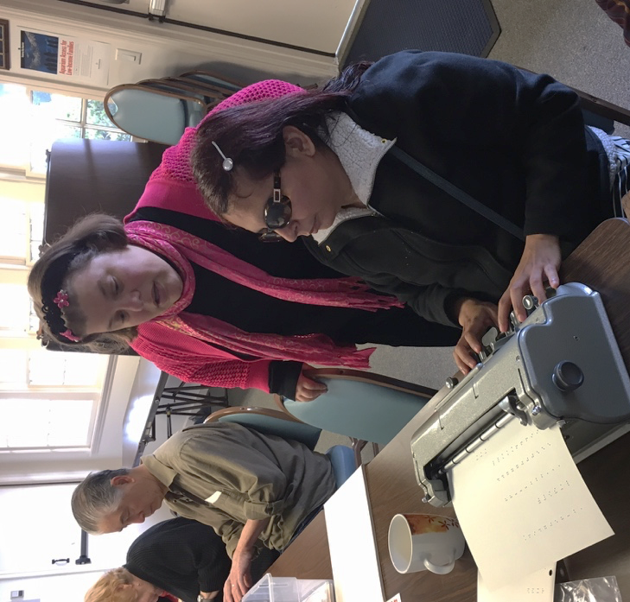

Chariots for Charity
Operated by the Old Capitol Lions Club, Chariots for Charity vehicle donations support the BVIC with cash donations from the sale of donated vehicles. For more information or to donated a vehicle, please contact Russ Hatch at 831-659-5360.

