BLINDFOLD

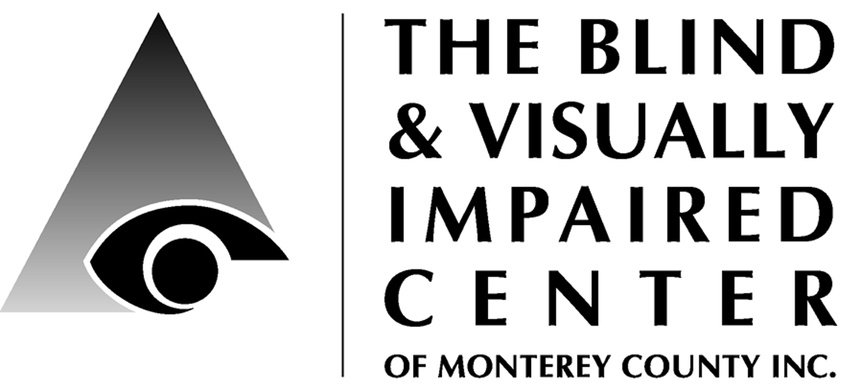

225 Laurel Avenue, Pacific Grove, CA 93950 (831) 649-3505 www.blindandlowvision.org

Summer 2017

NEWS & ANNOUNCEMENTS

Country Store Auction
Saturday, October 28
10:00 am – 2:00 pm
Free Admission

Be sure to save the date and plan to join us!
This fundraising event will feature:
- Homemade Sweets & Baked Goods
- Client made Crafts
- Silent Auction
- Live Entertainment
- Light Refreshments

Proceeds benefit The BVIC and will support direct client services. To donate to the Country Store or Silent Auction, please contact Diana at the office: 831-649-3505.

Community Outreach is a growing service offered by the BVIC. We provide basic low vision training to other service providers, attend health fairs and/or present informational sessions at senior living communities and in the wider community.

If you would like us to visit your living community or attend your community event, please contact Sam at 649-3505.

New O&M Position
In keeping with our new strategic plan to evaluate program needs and add additional staff: The BVIC is pleased to announce we are looking for a full-time, dual certified, bi-lingual (English-Spanish) orientation and mobility specialist.

If you know someone who may be interested or if you are interested in applying for this position, please contact Diana by emailing vision@blindandlowvision.org and she will send you the job description.

Peer Support Groups
Please contact Karen: 649-3505 x104.
English:
- 1st & 3rd Tuesday from 10:00-11:30 a.m. at 225 Laurel Ave, Pacific Grove
- 2nd & 4th Thursday from 10:00-11:30 a.m. at St. Ansgar’s Lutheran Church, 72 E. San Joaquin St., Salinas
Spanish:
- 1st & 3rd Thursday from 10:00-11:30 a.m. at St. Ansgar’s Lutheran Church

Facebook
Stay up to date on current news and events by following us on Facebook: https://www.facebook.com/BVICenter/

Website
Visit our website to learn more about our services and find helpful resources.
www.blindandlowvision.org

Volunteer Opportunities
We are seeking volunteers to staff the front desk, answer the phone and greet visitors: 9:00am-1:30pm Tuesday, Thursday or Friday.

Tuesday Ceramic Art Class Volunteers:
Tuesdays from 11:00am – 2:00pm with lunch or 12:00noon – 2:00pm without lunch.

Audio Library: organize, label and catalog on an excel spreadsheet (requires you to bring a laptop). About 2 hours/month.

Apple Store Discover Accessibility Classes
The BVIC is pleased to collaborate with the Apple Store, Del Monte Shopping Center to provide "Discover Accessibility" workshops on the accessibility features of the Mac and iPhone/iPad. To sign-up, visit their website: https://concierge.apple.com/workshops/R305/en_US/

Audio Library. Did you know that BVIC has a small but growing audio library of CD and MP3 books? Books, which are donated by clients and supporters, are located in our self-serve library which is maintained by volunteers. If you would like to help maintain the library, please contact Diana. It only takes about two hours/month and requires a laptop, basic excel to add new titles to our list, and alphabetizing the books on our shelf.

The Pacific Grove Butterfly House
Full of vivid colors and beautiful butterflies of all colors, shapes and sizes, the Pacific Grove Butterfly House is a labor of love. Located at 309 9th Street in PG, this magnificent house is a one of a kind creation. It is a wonder for viewers of all ages.

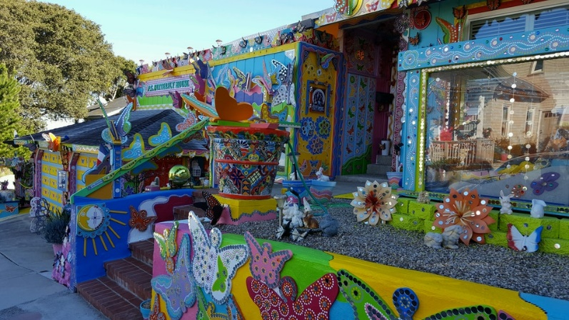

This extraordinary work of art was started when owner J Jackson learned his wife Sonja was diagnosed with the eye disease retinitis pigmentosa. Learning that this disease would soon leave her unable to see anything except very bright colors, J picked up his paintbrush, released his inner artist and began transforming their home into a delight for the eyes to behold.

Not only does the PG Butterfly House bring smiles, joy and laughter, it also supports the BVIC. For a donation of $20 or more, visitors can purchase a butterfly from J - the Butterfly Man, have the name of a loved added to it, and then it will be placed on the Wall of Love!

So far this year the Butterfly House has donated more than $1,000 to support services provided at the center. Be sure to stop by, marvel at the wonder of this magical enchanted wonderland and ask the Butterfly Man to add a butterfly for someone you love!

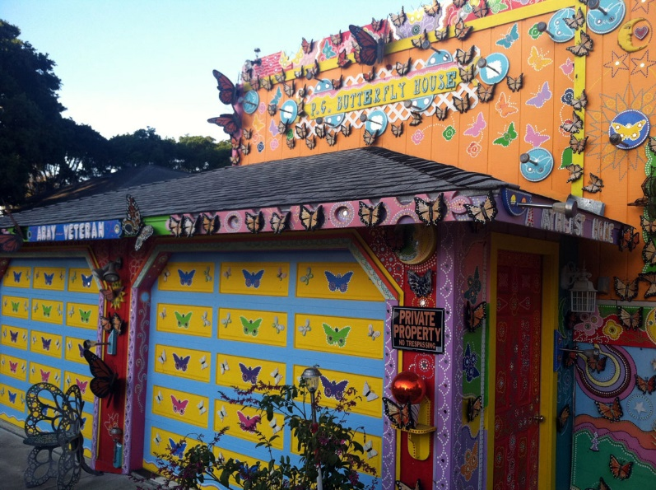

President’s Message
Dr. Ken Hunter
How adamant are you about your ocular health? If you’re like Jennifer Anniston, you practice “eye love,” according to her recent television commercials. We are bombarded with advertisements about our health in general. We’ve all seen the commercials regarding irritable bowel syndrome, bladder leaks, constipation, and hemorrhoids. Do we really want to answer the question, “How Cottonelle do you feel?” Sheesh! Enough already.

Seriously, our eye health is not to be trifled with. St. Paul lost his vision on the road to Damascus. His vision was about to get a major transformation. We, too, can envision a different perspective if we only allow ourselves to seek the help we need. St. Paul wrote to the Corinthians that our bodies, i.e., eyes, are the temple of the Holy Spirit. Our eyes are often referred to as the “window to our soul.” It makes sense that we should nurture our eyes with tender-loving care. This is where the BVIC comes in.

Our team of rehabilitation specialists are prepared to assist you in achieving the maximum from your usable vision through magnification, assistive technology, orientation and mobility, and education. We pride ourselves in helping those with vision loss who are looking for more perspective, like St. Paul. Our low vision clinic provides a useful tool to determine what your vision is capable of achieving. Through this scientific analysis, the Blind Center can make recommendations about services, equipment, and training.

I assure you, that you will be amazed at the technology we can bring to bear on your eyesight. Give us a chance to intercede on your behalf. We pick up where your ophthalmologist and optometrist leave off. We don’t claim to restore your vision but we do suggest that we can give you a new perspective. Pick up the phone and call us today about your vision concerns. Isn’t it time that you, too, practiced a little “eye love?”

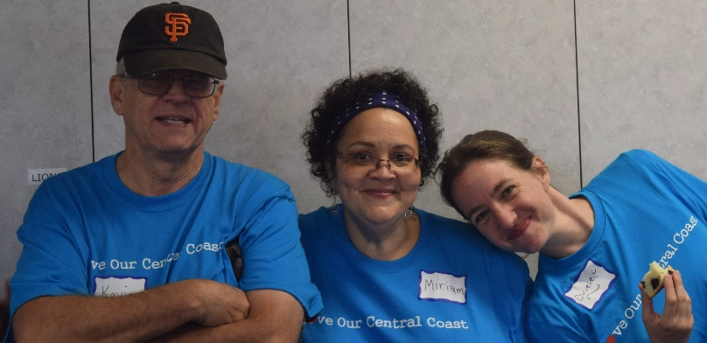
Love our Central Coast Volunteers!

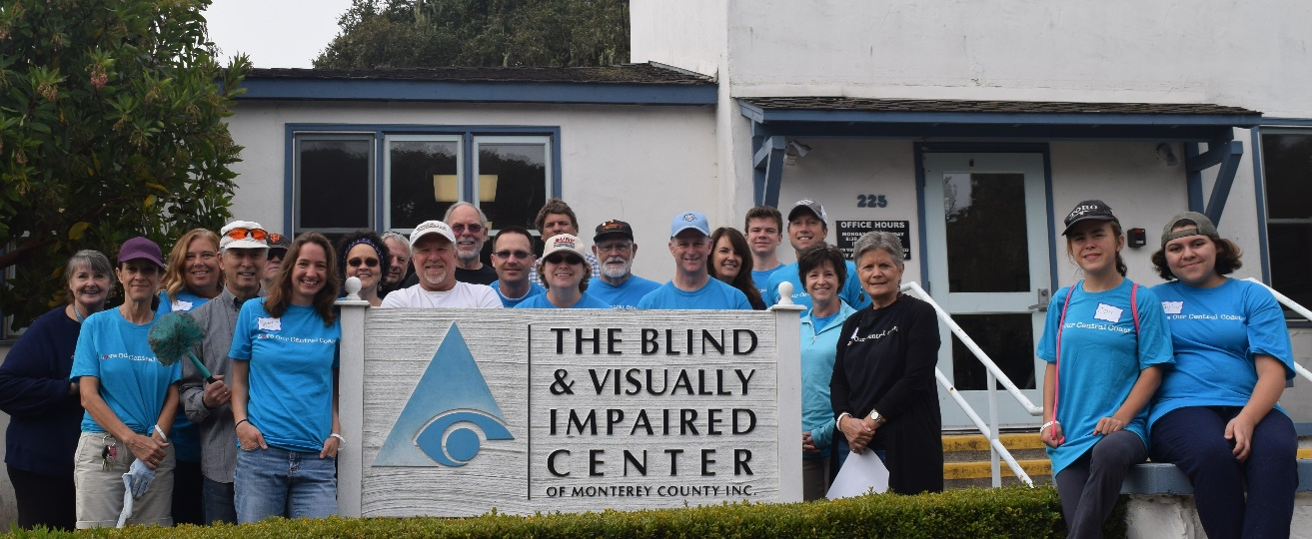
Love Our Central Coast – Clean-up Day
On Saturday, August 26th more than two dozen volunteers arrived at the BVIC equipped with smiles, enthusiasm and gardening and cleaning supplies. Their mission – to spruce up the center by deep cleaning inside and out and to help prevent erosion by installing drainage gravel around the building and in the garden beds.

Love Our Central Coast is a Church Partner Service Project Movement with the goal of loving and serving Monterey County residents and organizations. It features a day of service to over 48 project sites. To learn more visit: http://www.loveourcentralcoast.org

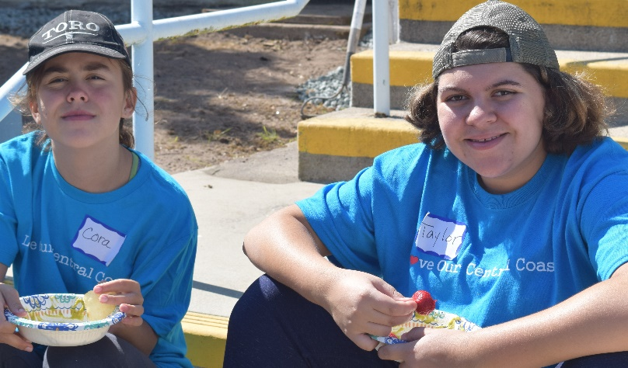

The BVIC was blessed to be chosen as a project this year.

Volunteer leaders, Bill and Deborah Warne, spent many hours beforehand to meet with BVIC Executive Director, Diana Trapani to define the project, recruit volunteers, and gather the needed supplies, including four tons of gravel.

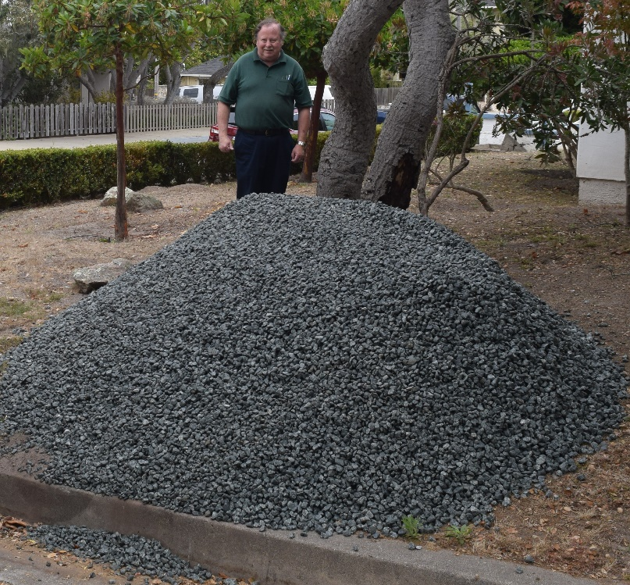

This happy and hardy group laughed, smiled and shared stories as they climbed ladders to clean windows and upper cabinets; crawled on knees to scrub baseboards and lower cabinets; stretched to ceiling corners to remove cobwebs, rolled wheelbarrows of gravel, raked leaves, and got wet while power washing to ensure they left no speck of dust, spider webs or finger smudges in sight!

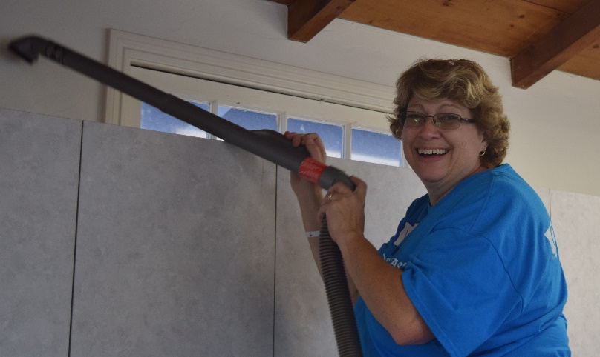

Russ and Jo-Ann Hatch of the Old Capital Lions Club provided beverages, snacks and cheers to fuel the hard-working volunteers.

We send our heartfelt thanks to everyone who donated their Saturday and boundless energy to spread the love and leave a sparkling clean center.

See more photos at their website:
https://drive.google.com/drive/folders/0B-T5wgltI_CINjl4QTdGX1VzM1k

“Blind People Don’t Watch TV!”
What is Audio Description, Video Description, or Described Video?
By Becky Stewart, Member BVIC Board of Directors
I first met Gregory Frazier in 1984. Gregory had just completed his broadcasting master’s thesis at San Francisco State University in “television for the blind,” that developed underlying audio description concepts. A pioneer in the field of audio description, he became inspired because his boyhood best friend was a young visually impaired boy.
Unlike describing scenarios informally to visually impaired family and friends, Frazier’s approach followed “scripted” audio description. He became a teacher at SFSU, and Professors Gregory Frazier and August Coppola, founded the AudioVision Institute at San Francisco State University. Simultaneous description for Francis Ford Coppola’s 1988 movie, Tucker, was one of their projects, and the first movie audio described.

I became involved in their educational study of sighted and non-sighted high school students with the movie, Never Cry Wolf. Randomly selected sighted students viewed the movie, not audio described, and took a comprehension test afterwards. Another group of students, also randomly selected, watched an audio described version of Never Cry Wolf, and took the same comprehension test. The final group of students assessed was mainstreamed visually impaired high schoolers who viewed the audio described version of the movie.

The results of the study proved surprising. The highest performing students on the comprehension test were the visually impaired students. Second highest performing was the group of sighted students who viewed the audio described version of the movie. The lowest performing group was the sighted students who watched the movie in its “normal” undescribed format. That’s when I became an advocate of scripted audio description of live theater, television, movies, art, national parks, and museum exhibits.

Once unheard of by many visually impaired consumers, audio description of television and films has now become a standard and regular form of their entertainment. Also referred to as a video description, described video or DVS, and more precisely called a visual description, it is an additional narration track of visual media (including television, film, dance, opera, and visual art).

The length of descriptions and their placement by a producer into the program are largely dictated by what can fit in natural pauses in dialogue.

In the mid-1980s, WGBH a PBS affiliated Boston television station, began investigating uses for the new technology of stereophonic television broadcasting and an audio channel called the Secondary Audio Programming (SAP). After national testing, Described Video Services (DVS) became a regular feature of selected PBS programming, including Masterpiece Theater and Mystery programs.

Based on the children’s book about a visually impaired aardvark, Arthur was developed for blind and visually impaired children. Today at its opening you will hear, "Arthur is an 8-year-old aardvark. He wears round glasses with thick frames over his big eyes. He has two round ears on top of his oval-shaped head. He wears red sneakers and blue jeans, with a yellow sweater over a white shirt."

For television, the audio description is termed video description in the USA and has historically been transmitted to the user via the Second Audio Program or SAP channel on the TV, which must be capable of receiving SAP signals. Most TVs manufactured since the early 1990s are equipped to receive SAP, which is usually activated through the MENU button on the remote. Always check your television’s manual under Accessing Audio Description. Additionally, with the transition from analog to digital TV, things are changing. Contact your cable company for information regarding accessibility.

In theaters and similar venues, the user hears the audio description via a small earpiece or earphones connected to a tiny receiver. For movies, mainly available in AMC Theatres, the description has been prerecorded and synced to the movie soundtrack. For live performances, a trained Audio Describer transmits the descriptions from elsewhere in the theater. Many live theatre productions such as Hamilton, and Hello, Dolly are currently being described in San Francisco or San Jose.

For videos distributed on DVD, the audio description, when available, is accessed via the DVD menu for the movie as a special feature of the Languages menu. The track can be located simply by repeatedly pressing the Audio button on the remote. Many libraries distribute DVDs or VHS tapes of older movies with audio description added.
If you are a Netflix subscriber, you are in luck. In 2015 Netflix committed to begin audio description of their original series, starting with Daredevil, which features a blind protagonist with other heightened senses. The remainder of their original programs such as House of Cards, Fuller House, and Orange is the New Black is all audio described. To date Netflix has over 400 offerings. To view a listing, log onto https://help.netflix.com/en/node/25079.

In June of this year, Amazon Prime video service announced they launched video description for more than 100 movies from The Hunger Games to The Big Short. Additionally, Amazon original series like Bosch, The Man in the High Castle and Transparent are also described. Subscription customers can view titles with audio descriptions by going to http://www.amazon.com/video/audiodescription

ABC, CBS, NBC, Fox, PBS, USA networks, Disney channel, and the Turner Classic Movie station all have extensive described programming for the visually impaired. Modern Family, Globe Trekker, Criminal Minds, Law and Order, Mr. Robot, Master Chef and many more are all available to watch via SAP or Xfinity One cable service. For a partial listing of programs or for more information about video description, please feel free to contact the BVIC.

Experiencing many setbacks through the years, mainly due to lack of funding, 2010 proved to be a landmark year for the audio description industry and the visually impaired. President Obama signed the 21st Century Communications & Video Accessibility Act. The law prescribes incremental expansion of video description over a period of years to achieve 100 percent nationwide coverage. Today we are coming closer to achieving that than ever before, and many visual programs, inaccessible in the past, are continuing to be developed and offered to visually impaired consumers.

So, blind people do watch TV. They go to the theater to watch live performances, and they rent DVDs. They subscribe to Netflix and watch the latest popular programs downloaded on their IPhones. Not being able to consume the same culture as everyone else isn’t just an inconvenience—it keeps visually impaired people separate from society. Thank goodness that is changing thanks in part to my friend, Gregory Frazier, who unfortunately passed away in 1996, never to see the progress audio description has made. He would be delighted!

Blind Musicians…Dancing Dots
Karen Levin, VRT
Music is universal. In many cultures, music is a very important part of people's way of life, as for some it plays a key role in religious beliefs, rite of passage, graduation, and other joyous occasions, as well as hobbies for others. Music allows us to express ourselves. Music can provide individuals with the opportunity to develop an appreciation for various types of music. Many can develop their own mode of self-expression; develop better listening skills; use positive expressions of feelings; improve coordination and rhythm; increase language skills; develop awareness of rhythm and develop space awareness through movement.

For those with visual impairments it is hard to see the printed notes, but having a good ear to hear the sound, pitch, rhythm, speed and volume are all important factors for music. And there are products which help visually impaired musicians create their art. Dancing Dots is just one of these products.

Since 1992, Dancing Dots has been making accessible music technology for the blind and visually impaired. They offer technology, educational resources and training to assist individuals to read, write and record their music. Their products and services foster inclusion, literacy and independence for visually impaired musicians and audio producers engaged in educational, leisure, and professional pursuits. Musicians can independently create print and Braille scores, as well as record, mix and master audio projects.

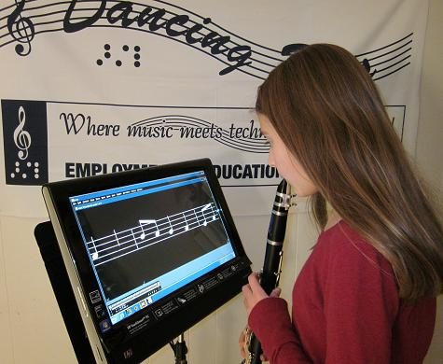

Using Lime Lighter, low vision performers can read magnified print music up to ten times standard size. GOODFEEL Braille Music Translator, converts print music to Braille. Visit dancingdots.com to learn more about their services and products.

Since we are talking about visually impaired musicians, I want to highlight the following four inspiring artists:

Stevie Wonder. In 1950, he was born six weeks early and blind. Early in life he showed a gift for music, mastering the piano, harmonica, drums and base, all of which he taught himself before age 10. He was considered a child prodigy, making his recording debut at age 11. Although he had a private tutor when touring, Stevie later attended the Michigan School for the Blind where he studied classical music. In addition to music and film, he is known for his international activism, working to improve services for the blind and people with disabilities around the world. In 2014, he received the Presidential Medal of Freedom.

Ray Charles was not born blind, but had lost all sight by age 7. Music came naturally for him. While attending the Florida School for the Deaf and Blind, he received his formal education in classical music. He had a growing interest in Jazz and Blues and from that began to develop his own musical style. Pioneering the soul music genre, he combined blues, rhythm and blues and gospel styles. Ray contributed to the integration of the music industry by recording in country and pop music genres. Always a student and always striving to expand his music, Ray received 8 honorary doctoral degrees, 17 Grammys, the Grammy Lifetime Achievement Award and the President’s Merit Award.

Laurie Rubin -Born blind in southern California, Laurie is a Mezzo-soprano. Her forte is Opera, but also sings other genre’s. With strong support from her family, she attended public school and summer camps, and even had the Torah translated into Braille and had the first blind bat mitzvah at her synagogue. She continues working to dispel stereotyping. A rising opera star, she has performed at Carnegie Hall and the Kennedy Center; and is co-founder of the Ohana Arts - Performing Arts Festival and School in Honolulu for children, both blind and sighted.

Diane Schuur – Born blind and nicknamed “Deedles”, this two-time Grammy award winner is a white, female jazz singer. She attended the Washington State School for the Blind. While self-taught on the piano, she received a formal music and piano education. She has played at Carnegie Hall and the White House during the Regan administration. In 2000, she was awarded the Helen Keller Achievement Award by the American Foundation for the Blind.

“Hello Darkness, my old friend.”
Samantha Kelley
I am sure this will not come to a surprise to anyone who has read my articles in the past, but I have, once again, come upon a very interesting story while listening to the BBC. The story is of a blind man and how he came to a place where he is offering three million dollars of his own wealth in gold to anyone who can cure blindness (or anyone who comes closest in the way of research); This man is Dr. Sanford Greenberg, or Sandy as he is known to his friends.

In the 1960’s, Sandy lost his sight at the age of 19 while attending Columbia University.
Although he was discouraged and overwhelmed, a good friend encouraged him not to give up on his studies and did all that he could to help. You may recognize this friend’s name – Arthur (Art) Garfunkel. The two met at freshman orientation and became fast friends. Every night they would sing in their room, Arthur on guitar and Sandy on drums. Neighbors would come in just to listen. Their friendship deepening, Art & Sandy made a promise to each other to be there in times of crisis, which came sooner than later when Sandy’s vision was lost to allergic conjunctivitis. He thought it was temporary until, during his first final exam, he couldn’t finish because his vision went completely out. He was soon after diagnosed with glaucoma and the doctor said, “Son, you are going to be blind tomorrow.”

Sandy dropped out of Columbia, but between his girlfriend and Arthur, he was persuaded to go back. Arthur convinced him by reminding him of their pact about being there for each other in times of crisis. So, Sandy went back. Art would visit and read to him and, upon entering would say, “Darkness is going to read to you now.” Looking back, Sandy supposes that Art was thinking of his voice as emerging from the darkness. Art would frequently take Sandy to class, bring him back, and escort him to the city; He basically altered his entire life to help Sandy.

During one of their city outings, Art had led Sandy to Grand Central Station when he then told him he had to leave him because he had plans for the rest of the day and wouldn’t be able to escort him back to campus. Sandy was so angry, he just bolted, inserting himself into the crowd. Making his way back to campus, he cut his forehead, his shins, etc.

“The darkness was bringing me down… it was a horrendous feeling of shame and humiliation.” A few hours later, Sandy got back to campus and bumped into a man who said, “Oops, excuse me sir.” He knew the voice; it was Arthur. At first, he was enraged, until he understood Arthur’s strategy. As it turns out, he had followed Sandy the entire way, realizing that whatever words of encouragement that he would give ultimately would be insufficient. Sandy needed to know that he could do it on his own. That moment defined Sandy for the rest of his life and, afterwards, he felt he could do anything he wanted to do.

After they graduated, Sandy went on to grad school at Harvard and was offered a scholarship to study at Oxford. At that point, Arthur called and said he wanted to drop out of architecture school because he wasn’t happy and wanted to go into business with his friend. You know him as Paul Simon. Of course, Sandy asked how he could help and Arthur said he needed $400 to get started. He had $404 in his checking account at the time and Sandy felt his request was a “monumental gift” because it was the first time Sandy could live up to his part of their pact. So, that is how Art Garfunkel and Paul Simon were able to record their first album. I am sure we are all familiar with the opening line of The Sound of Silence: “Hello Darkness, my old friend.” Knowing this story, it now takes on a different meaning, or at least it did for Sandy.

Sandy never forgot what it felt like to feel helpless that day as he made his way blindly back from Grand Central Station. It is what helped him to become so successful in his efforts. After hearing J.F.K. announce his goal to send man to the moon within a decade, Sandy vowed to do everything he could for the rest of his life to make sure no one else would go blind. “And, of course it was ludicrous and insane, but that was my commitment,” Sandy describes.

So, he launched an initiative in 2009 to end blindness by 2020. He is offering a prize of three million dollars in gold because gold is a reminder of the beautiful sunset he remembers the last day of his eyesight. “Creating an inspirational promise and an aspirational goal.” When his commitment was announced, it was done by none other than his good friend, Art Garfunkel, who said, “We are searching for nothing less than light.”

(Story from BBC World Service – Outlook Series – “The Musician of Mosul” Episode)

Do I need sunglasses? YES!
Jenny Swad, CLVT/COMS
Making the choice to wear non-prescription sunglasses, we call them filters or tints, can have an astonishing effect and here is why:

Selecting an appropriate filter can minimize eye discomfort and maximize remaining vision. But how do we find the best filter? This is dependent on your own thoughts about what feels soothing to your eye. Ideally, your local Orientation and Mobility instructor and/or Low Vision Specialist can help you determine the best filter by providing an assessment while taking a short walk or sitting outdoors in your favorite outdoor area. This assessment requires balancing light sensitivity issues with appropriate filter color selection.

Some people may even benefit from wearing a filter indoors in order to control issues with overhead light and bothersome light from windows. I highly recommend trying a pair of tints indoors if you find that you spend your day with your window blinds closed, thereby blocking healthy light that our bodies need for our state of mind. Once you’ve made the decision to wear your carefully selected filter, you will have quickly reduced bothersome light and glare issues caused by AMD and other eye conditions and you will experience less frustration related to eye strain and go about your day with more ease.

More about light and why tints help:
This absorption of visible light and ultraviolet light by sunglasses protects the retina against long-term exposure to high-energy wavelengths, which are associated with the deterioration of the center of the retina. More specifically, shorter wavelengths of the visible spectrum can scatter and bounce around in our eye and cause damage. By wearing the right type of tints, we can control the type of visible light and wavelengths that reach our sensitive eye. When we control what kind of light goes into our eye, we can aid in the management of our depth perception and contrast.

Not all sunglasses are created equal, and that does not have to do with price. In low vision therapy we are concerned with sunglass frames that block out light in all directions and not just straight ahead. Be sure to find tints that have full protection in all the areas, they are typically called fit-over tints or wrap-arounds, depending on whether you wear glasses or not. You may be more comfortable wearing clip-on tints or flip-ups, but keep in mind that certain harmful rays of light are finding their way into your eye from the open areas. Ideally you could walk into a shop and find the best frame size, color, and light transmission available, but it would take a warehouse to hold all the options. For now, be concerned about the color of the lens and not wearing something too dark that will take away your remaining vision. The most common tint colors are yellow, amber, gray, and sometimes plum. Various colors boast benefits such as mentioned earlier.

Non-prescription tints can offer polarization as an option. Polarized sunglasses keep you protected from light-waves that are reflecting from horizontal surfaces, we mostly think of the ocean as offering harsh glare, so for those of you that are around water frequently, polarized tints would be recommended. Other types of glare are known as discomfort glare caused by the sun, so wear a hat, and veiling glare caused by cataracts.

There is so much more to know about how color and light can affect our perception and scientifically work on or against our behalf. To learn more, search the internet, visit an optometrist, or come into the BVIC and speak with the Low Vision Coordinator.

A Tidbit About Prisms
Dr. Katie Wendt, OD
If you are asked to imagine a picture of a prism in your mind, perhaps you picture a triangle with white light going in on one side and a colorful rainbow of light emerging slightly bent from the other? (I seem to recall a Pink Floyd album cover from decades past.) Besides splitting white light into individual wavelengths, prisms are useful and prescribed with regularity for ameliorating some causes of double vision.

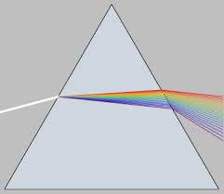
A prism separates white light into its constituent colors.

Prisms are utilized in eyecare because they displace the location of an image viewed through them—a way to address double vision and certain kinds of eyestrain, either congenital or acquired.

When a person is born with a large eye turn, surgery is usually the answer. In less severe cases however, vision therapy and/or prisms are the better option. Later in life, people may acquire double vision secondary to diabetes or head trauma. Some cases of double vision resolve after a short duration. During this waiting period, temporary prisms called Fresnel prisms can be prescribed and applied to spectacles.

You may recall, not too long ago, Hillary Clinton suffered a concussion because of a fall. Shortly after, she testified before congress wearing glasses with a lens that looked a bit unusual. This unusual lens was a Fresnel prism, likely worn because she was experiencing some double vision. Prisms are also prescribed for certain cases of visual field loss—those which are a result of a brain tumor or stroke for example. In such cases, a sector prism applied to a patient’s spectacles improves mobility by bringing awareness of obstacles in that person’s path.

Training the patient to scan into the missing field is a crucial part of the success of prisms that aid in mobility. When permanent prisms are indicated, they can be ground into a patient’s prescription glasses.

We have Isaac Newton to thank for his work in the 17th century enabling us to understand the refraction (bending) of light as it passes through prisms.

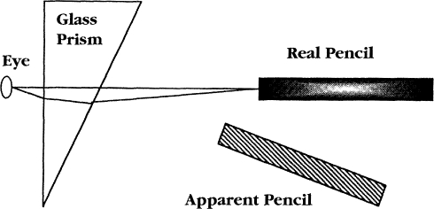

A prism changes the apparent location of an item viewed through it.

SUPPORTING BVIC
Your Vital Support
BVIC’s 2017 annual operating budget is about $572,000. This is about $11,000 each week to cover expenses including staffing and payroll costs, program equipment, IT, overhead, and other costs such as this newsletter.

Your support is vital to ensuring we continue to offer our free low vision, vision rehab, and orientation & mobility services, low cost low vision clinic, qualified staffing, free materials, and outreach services.

Please consider how you would like to support the center and send your gift to cover:
$11,000 one week of costs
$ 5,500 half-a-week
$ 2,200 one day
$ 1,100 half-a-day
$ 275 one hour
$ 138 half-an-hour
The clients thank you for your generosity!

Chariots for Charity
Operated by the Old Capitol Lions Club, Chariots for Charity vehicle donations support the BVIC with cash donations from the sale of donated vehicles. Operated since 1985, the Chariots program has raised more than $300,000 to support BVIC!

For more information or to donate a vehicle, please contact Russ Hatch at 831-659-5360.

Shopping to Support BVIC
eScript on-line.
To sign-up simply register your phone number and select: eScrip Group ID – 500024165 Blind-Visually Impaired Ctr Monterey Co;. https://secure.escrip.com/signup/index.jsp,
eScript is good with hundreds of participating merchants.

Goodshop
Select Blind and Visually Impaired Center – BVIC to benefit from your use of Goodshop. www.goodsearch.com. Don’t forget to download their mobile app!

Benefit-Mobile is a free app you download to your smart phone, purchase cards to your phone and use when you check out. Visit: www.benefit-mobile.com to sign-up, select The Blind & Visually Impaired Center of Monterey County as your beneficiary.

Braille Classes
For older adults who can no longer see well enough to read, braille can be a very useful skill and tool. Braille can be used in everyday communication, can help one locate the right elevator floor and office suites, and can be used to label many items, such as food, medicine, household objects and DVD's.

Our first group of students are learning, laughing and progressing well with their beginning braille lessons. If you are interested in learning braille, please call Karen 649-3505.

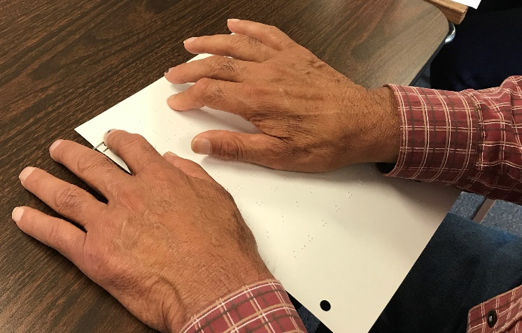
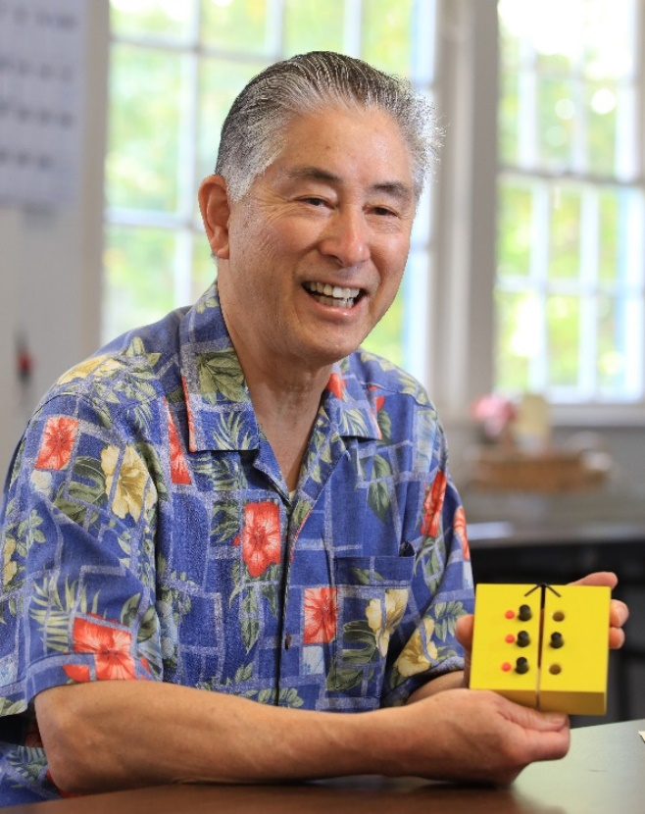

We extend our heartfelt thanks for your support in 2017! Donors: April 1st –
June 30th.
A&E Low Vision Products
Access Ingenuity
Altrusa International of Monterey Peninsula
Amazon Smile
Angello, Michelle
Anloff, Patricia
Anonymous
Axe, John
Ayres, Tony
Banks, David & Wendy
Bloxom, Bruce & Anne
Bohn, Margaret
Britton, Robert
Brown, Elizabeth Plaxton
Budlong, Ned & Celia Barberena
Butterfly House
BVIC Fund at CFMC
Cannon, Thomas
Capital One Bank Rewards
Cardoza, Joan
Chariots for Charity
Chavez, Agueda & Rosa
Chiappe, Elio & Gerry
Christin, Mary Margaret
Church Women United Monterey Peninsula
Clinica de Salud del Valle de Salinas
Cocker, Enid
Cocklin, Norma
Covarrubias, Fernando
Craft, Nick & Becky
Craig, Jeff & Carolyn
Cruz, Celeste
D'Arrigo Bros. Co.
David, Beverly
Davidson, Erik & Lori
Diaz, Herminia
Disability Communications Fund
Dorman, Ann
Dunn, Richard & Virginia
Dwyer, Ellen
Enea, Frank
Episcopal Senior Communities
Eschenbach Optik of America
Escript
First Baptist Church of PG
Fiske, Ernest
Fletcher, Rolland & Jennifer
Forest Hill Barber Shop
Freedom Lions Club
Gamble, Richard & Barbara
Gardner, Tom & Sylvia
Gasperson, Jayne
Gaver, Donald
Gehringer, Helen
Glazier, Carol
Gonza Events
Gordon, Dorothy
Gross, Sabreh
Gryp, Janice
Gularte, Ray & Lillian
Gunderson, Gary & Tab
Hagey, Dolores
Hale, John
Hanson, Janet
Hart, John
Hattori Vision
Hough, Sonia
Hunter, Ken
Huntington, Louis
Hutchins, Charles
Hutchinson, Antonina
Irwin, Martin
Jackson, William & Sonja
James, Paul & Ellen
Johansen, Bud
Johnson, Betty
Johnson, Bob
Johnson, Harry & Joan
Kalber, Audrey
Kane, Steve
Kaufman, Lisa Paula
Kihara, Ron & Ann
Kissel, Helen
Labbe, Theona
Larez, Marie
Lions Building for the Blind
Lions Club Marina
Lions Freedom
Lions Salinas Host
Lipp, Marty & Natividad
Livingston, Barbara Timmons
Loop, Mel
Lundy, Jane
Lyon, Willis
Mamat, Jane
Marjorie McNeely Fund for the Blind or Illiterate of the CFMC
McBee, Gloria
McCormick & Co
MCGIVES!
Mehl, Geneva
Miguel, Heidi
Mike's Appliance
Moe, Alice
Monterey Peninsula Foundation
Morris, Randall
MPVS Thrift Shop
Network for Good
Nicholson, R. L. & Katherine
Nicolai, Adolph
Norman E. Wiley Admin. Trust
O'Connor, Paula & Dennis
Old Capitol Lions Club of Monterey
Osoria, Pedro & Inge
Ozenne, Helga
Pacific Grove Cleaners
Pacific Grove Hardware
Pacific Grove Lions Club
Pacific Thai Cuisine
Parenti, Margaret
Parham, Judith
Parsons, Julie & Howard Worth
Peasley, Barbara
Peel, Alan & Elinor
Peelo, Beatrice
Peninsula Gem & Jewelry
Pepperdene, Rose Faye
Pesce, Thomas & Nancy
Piro, Vincent & Martha
Prunedale Lions Club
Radunich, Margaret Anderson
Patricia Smith Ramsey Trust
Randall & Patricia Morris Donor Advised Fund of the Silicon Valley Community Fdn
Reinstedt, Debbie
Rivera, Alfonso
Rubin, Steven & Helen
Ruhl, Pauline
Salinger, Rusty & La Rue
Sargisson, Stuart & Lisa
Schoenwisner, Mona
Schure, Carmelina
Schwoerke, Karin
Segel, Constance
Setinek, Carol
Sherman, Mary
Smith, Clara
Smith-Scharf, Sherril
Spencer’s Stationery
Squires, Walter
Stallings, Betty Jean
Stengel, Naidene
Stewart, Bob & Becky
Streeter, Thomas
Swerrie, Allyne
Tackett, William & Vicki
Taste Cafe & Bistro
Teixeira, Sylvia
Thompson, Stella
Tobi Cares / TOBI.COM LLC
Torrero, George
Tragethon, Jan
UBS Matching Gift Program
Uchida, Kiyoko
United Way of Central Maryland
Weeth, Lois
Wenzel, Maggie
Williams, Jeanne
Wills, Tom & Judy
Wodecki, Andrew
Wylie, Judith
Ziegenbein, Constance

In Memory or Honor of:
Shahin Anable
- Anable, Leonard
Carolyn Craig
- Paul, Betty
Tracey Gate
- Plastini, John & Marion
Kathy Henson
- Colvin, Gloria
Fred Hinds
- Jamieson, Elizabeth
Ken Hunter
- Hatch, Russ & Jo-Ann
Bob Johnson
- Anable, Leonard

My Mother Elsie
- Dalkey, Sharon
Be Swartley
- Sabih, David & Anna Swartley
Tuesday Support Group
- Thomas, Douglas & Barbara

Endowment Fund
Did you know that over the years, many BVIC clients and donors have left a bequest to the center? Their gifts have been used to establish a modest endowment fund. The Board uses earnings from the fund to expand programming, purchase equipment or supplement the annual operating budget. However, they never invade the principle, and strive to leave earnings in the fund to build the base for future needs.
Kathy Henson Legacy Society
By including BVIC in your estate plans, you can help others in the coming decades transcend the loss the sight with a legacy gift.

Sample bequest language: “I give, devise and bequeath to The Blind & Visually Impaired Center of Monterey County, Inc., a nonprofit corporation of the State of California, located at 225 Laurel Ave., Pacific Grove, CA 93950, (tax identification number 23-7221588), [amount, %, specific items, etc.] of my estate.”

By including the BVIC in your estate plans, you can help build the endowment base to ensure a strong future for the BVIC and quality services for our next 46 years of service to the visually impaired community.

For more information, please contact Diana Trapani at the BVIC office: (831) 649-3505 or email vision@blindandlowvision.org.

