BLINDFOLD
225 Laurel Avenue, Pacific Grove, California 93950 831-649-3505 www.blindandlowvision.org
Spring 2021

NEWS AND ANNOUCEMENTS

Response to COVID-19
The Blind and Visually Impaired Center of Monterey County resumed in-office operations on Monday, July 6, 2020. Following strict State and local health guidelines, along with implementing new office protocols, we have made the following changes to our office:
- Implemented social distancing procedures;
- Implemented hourly and daily disinfectant procedures;
- Implemented a staff wellness plan, including daily temperature checks;
- Implemented bi-monthly support groups via Zoom;
- Limited office hours and client/staff interactions.

Braille and Ceramic Classes
In compliance with State and local Shelter-in-Place Orders, braille and ceramic classes are cancelled until further notice.
Peer Support Group
In response to COVID-19, The Blind and Visually Impaired Center of Monterey County resumed bi-monthly support groups via Zoom in April 2020. The support group is peer led and meets the first and third Tuesday of the month at 10:00 a.m. For more information, including Zoom access, contact Steven Macias, Executive Director, at 831-649-3505.

Community Outreach
Community Outreach is a growing service offered by The Blind and Visually Impaired Center of Monterey County. We provide low vision training to service providers, attend health fairs, and present information sessions at senior living centers and in the wider community.

To submit an event invite or demonstration request for 2021, contact Steven Macias, Executive Director, at 831-649-3505.

Contact Us
The Blind and Visually Impaired Center of Monterey County, Inc.
Address: 225 Laurel Avenue, Pacific Grove, California 93950
Telephone: 831-649-3505
Toll-Free: 1-800-404-3505 (in Monterey County)
Fax: 831-649-4057
Email: vision@blindandlowvision.org
Website: www.blindandlowvision.org
A MESSAGE FROM TOM GARDNER, BOARD PRESIDENT
As we enter the second year of COVID-19, a lot has changed at The Blind and Visually Impaired Center of Monterey County. For the first year, programs were either moved to an electronic format or suspended. However, as the restrictions wind down, the Center looks forward to resuming all program activity and serving the individuals in our community who suffer from vision loss. We anticipate in July, once the restrictions in California and Monterey County are lifted further, to resume ceramics, in-person support groups, braille, and luncheons.

We are also looking to expand our presence in Monterey County by partnering with local Lions Clubs in our community to bring back the AJ Robinson, which would serve as our mobile low vision clinic and other health screening unit. With the funding our Executive Director, Steven Macias has procured, we can begin to travel to areas that are in desperate need of our services.

Lastly, The Blind and Visually Impaired Center will be celebrating 50 years of service to our community and our clients. Plans are still underway to celebrate this important milestone. Keep an eye out for a special edition of the Blindfold in the coming months to launch our celebration.

We look forward to the rest of the year and hope you will join us in supporting the Center.

Sincerely,
Tom Gardner
Board President

PRODUCT SHOWCASE: WEWALK SMART CANE
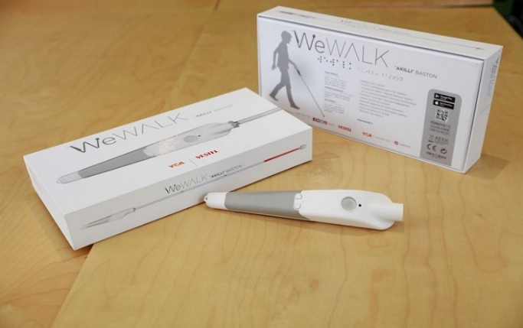
WeWALK Smart Cane acts as a new handle when attached to any long cane and was designed to feel natural, allowing for normal cane usage. When walking, WeWALK vibrates to inform you of low-hanging obstacles that the bottom of a cane may typically miss, such as a sign or tree branch. Additionally, you can pair your cane to the WeWALK app on your iOS or Android device via Bluetooth to make use of WeWALK’s smart features. These include finding your current location, checking public transport such as MST’s bus routes, and setting up voice alerts.

The WeWALK Smartphone App is free to download on iOS and Android. The company wants everyone in the visually impaired community and beyond to try it.

Schedule your visit with our assistive technology department to check out the WeWalk Smart Cane by calling The Blind and Visually Impaired Center of Monterey County at 831-649-3505.
A MESSAGE FROM STEVEN MACIAS, EXECUTIVE DIRECTOR
As we surpass the one-year mark of living in a COVID-19 world, our staff at The Blind and Visually Impaired Center of Monterey County has been exploring new ways to work with clients safely and effectively. We continually strive to provide the best support possible to individuals with vision loss.

On staff, our Orientation and Mobility Specialist provides instruction on purposeful, safe, and independent movement. Clients are taught indoor movement techniques, long cane skills, sighted guide, orientation skills, street crossing, and how to use public transportation.

Our Vision Rehabilitation Specialist works with clients on daily living skills to help them achieve real life tasks safely and with ease. These include how to maintain a household, kitchen safety, cleaning, organizational skill, cooking, handling money, and placing identifying markers.

The Blind Rehabilitation Specialist and Low Vision Clinic Coordinator works directly with our two part-time low vision Optometrist to provide demonstration, assessment, and instruction on the use of the most current assistive technology and devices available. These include CCTV’s, handheld magnifiers, talking devices, and lighting.

Without the support of our hard-working staff, our mission to empower the blind and visually impaired toward independent living would not be possible. I would also like to announce the return of Dr. Katie Wendt. She is returning to a regular schedule at the start of May.

While COVID-19 has slightly altered our business model, plans to grow the Center have significantly expanding. Currently, funding is in place to create a mobile low vision clinic. As the State and County ease restrictions on the Shelter-in-Place Orders, we anticipate starting the mobile low vision clinic in the second half of the year. Plans are also underway to establish a part-time Salinas office in partnership with Alliance on Aging. Lastly, thank you everyone who graciously donated through Monterey County GIVES! last year. In total, we received over $30,000 in donations, which is nearly a $6,000 increase over the prior year.

We have so much more to do. Your investment in our work will help with many of our programs and expansion efforts.

For any questions or comments, you can call me at 831-649-3505.

Stay safe everyone.

Sincerely,
Steven Macias
Executive Director
THANK YOU FOR YOUR SUPPORT FOR MONTEREY COUNTY GIVES!
On behalf of the Board of Directors, staff, and the especially the clients of The Blind and Visually Impaired Center of Monterey County, I am writing to thank those who donated for their generosity during this difficult time. This year, the Center received $30,028.87, which was almost $6,000 more than the previous campaign year. Your contribution allowed us to continue to provide services at little to no cost to residents throughout Monterey County living with vision loss.

I extend my sincerest appreciation and again thank those who were able to donate even with the hardships of the pandemic occurring.

If you would like to discuss ways to donate, including donations through PayPal or bequests, contact Steven Macias, Executive Director, at 831-649-3505 for any questions.

DR. KATIE WENDT RETURNS TO THE BLIND AND VISUALLY IMPAIRED CENTER
We are pleased to annouce that Dr. Katie Wendt has returned to The Blind and Visually Impaired Center of Monterey County with her regularly scheduled hours. Dr. Wendt is excited to be back at the Center and will begin seeing clients in May 2021. Dr. Wendt is available Tuesdays, Wednesdays and Thursdays for low vision eye exams.

Schedule your low vision eye exam with Dr. Wendt by calling The Blind and Visually Impaired Center of Monterey County at 831-649-3505.

PACIFIC GROVE ROTARY PROVIDES $2,500 GRANT FOR NEW ASSISTIVE TECHNOLOGY AND DEVICES
With the assistance from board member Dr. Celia Barberena, the Pacific Grove Rotary donated $2,500 to be used to procure new assistive technology and devices that allowed staff to showcase and provide new products to clients. With the grant, The Blind and Visually Impaired Center of Monterey County was able to purchase 144 assistive technology and assistive items. These included an assortment of canes, braille items, safety equipment, magnifiers, and lenses.

“We greatly appreciated the support from the Pacific Grove Rotary amidst the pandemic” said Steven Macias, Executive Director. “With the grant from the Pacific Grove Rotary, we were able to purchase and provide clients with assistive technology to help them lead a more independent life. With the pandemic, many of our clients are choosing to shelter-in-place. This new assistive technology and devices will allow us to demonstrate and bring the devices directly to our clients’ homes.”

The Center estimates these items can be used for years to comes and serve hundreds of clients throughout the years.

The Blind and Visually Impaired Center deeply appreciates the support from our local Pacific Grove Rotary.

Schedule your visit with our assistive technology department to check out the latest assistive technology by calling The Blind and Visually Impaired Center of Monterey County at 831-649-3505.
GIFT BASKETS STILL AVAILABLE
The Blind and Visually Impaired Center of Monterey County still has gift baskets available for a suggested donation amount. To view the gift baskets, visit blindandlowvision.org and click the link on the homepage. Baskets will be provided on a first-come, first-serve basis. Once a basket is paid for it will be removed from the website. Payment must be made through VISA or credit card by calling The Blind and Visually Impaired Center at 831-649-3505.

Contact Steven Macias, Executive Director, at 831-649-3505 for any questions.

AUDIO BOOKS
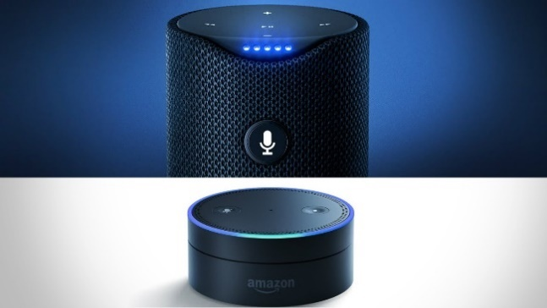
As many of us know, the Amazon Echo is a smart speaker that responds to voice commanders from the user. Once synced with your smartphone or computer, this device allows user to make phone calls to family and friends without having to press any buttons. This device can relay the weather forecast, read out cooking recipes, turn lights on and off if connected to a smart house, play games, and stream music. The device can also act as a voice reader for audio books through Amazon Kindle, allowing the user access to thousands of books.

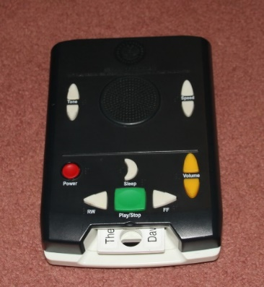
Additionally, the Braille and Talking Book Library offers free audio and braille books to individuals with vision impairments. Applications are free, and once filled out and sent to the library, their staff will contact you regarding next steps.

Individuals will receive an audio device that allows the user to listen to books on tape and magazines. Braille format is also available. The audio device is battery operated to allow the user to listen to books on the go and arrives with a self-addressed and pre-stamped return envelope to return the audio books once complete.

The Blind and Visually Impaired Center of Monterey County has their own audio library with over 600 audio books available. Schedule your visit to check out our audio library or get an application for the Braille and Talking Book Library by calling The Blind and Visually Impaired Center of Monterey County at 831-649-3505.

JOIN US AS WE CELEBRATE 50 YEARS OF MAKING A DIFFERENCE
The Blind and Visually Impaired Center of Monterey County will be celebrating 50 years of making a difference this August. Incorporated on August 12, 1971, we have been providing education and support for individuals living with vision loss since our creation. Although our programs have expanded, our mission has remained the same. We will be sending a special edition of the Blindfold in the coming months to promote our celebration and to serve as the kick-off of this achievement.
LOW VISION CLINIC
The Blind and Visually Impaired Center of Monterey County offers a low vision eye exam that focuses on retaining and improving current vision levels. Our eye doctors and clinician work with a variety of assistive technology to help our clients see better. The Center does not work with eye health, as that would still be handled by your regular eye specialist.

Some possible solutions we provide to preserve and improve remaining vision levels are:
- Glasses: If you have not gotten a pair of glasses recently, it might be time to consider an upgrade of your prescription. There are also high-powered reading glasses that help some individuals. We also offer a clip-on that goes on your existing glasses that provide an extra boost.
- Magnifiers: Sometimes glasses alone are not sufficient and people use a magnifier. There are hand-held and standing ones. Some provide illumination and individuals find this very beneficial. The powers of magnifiers at the Blind and Visually Impaired Center are stronger than ones that can be obtained over the counter.
- Electronic vision aids: These are a high-tech solution for some people. There are closed circuit televisions (CCTVs) that have a HD screen that ranges from 20 to 24 inches and a camera that printed material is placed under. Once the print material is in place, it shows up on the screen and can be magnified from 2 to 73 times the size of normal print. There are also portable video magnifiers that do the same thing but are smaller. The screens on these range from 3.5 inches to 12 inches and magnify print up to 22 times the size of normal print. Some of these devices have a text to speech feature that will also read print material to the person.
- Lighting: Some individuals with visual impairments find that extra lighting is extremely helpful. There are different types of lamps that help with this. Some are just task lights; others are lights with a magnifier.
- Glare and Contrast: We find that many of our clients often have problems with these. There are different indoor and outdoor filters that help in this area. Many have 100% UV protection; some have blue blockers for those who look at screens for extended periods of time. Both help with eye health. These glasses can be worn alone or as fit-overs that go over top of prescription glasses.
- Distance: Depending on individuals’ vision, there are different distance aids available. There are hand-held monoculars, ones that clip-on to existing prescription glasses, or are mounted in a frame. These can be used for short term spot-reading tasks, such as reading a street sign or store aisle signs, as well as for longer periods of time, such as watching television or movies, or viewing spectator events.

Schedule your visit with our assistive technology department to check out the latest assistive technology by calling The Blind and Visually Impaired Center of Monterey County at 831-649-3505.

BOARD MEMBER SONJA JACKSON TO BE FEATURED IN UPCOMING SENIOR RESOURCE GUIDE
The Best of Monterey Bay Senior Resource Guide will feature Board Member Sonja Jackson for the Senior Profile. Be sure to pick up your copy when available.
BOARD MEMBERS AND VOLUNTEERS
The Blind and Visually Impaired Center of Monterey County is proud to recognize their current 2021 board members, staff, and volunteer:
Board of Directors

- Tom Gardner, President
- Dr. Celia Barberena, Vice-President
- Alissa Whittle, Treasurer
- Sonja Jackson, Secretary
- Joe Desmond
- Dr. Gary Gray
- Randy Henson
- Toula Hubbard
- Dr. Ken Hunter
- Bob Johnson

Staff

- Steven Macias, Executive Director
- Martha Burgoon, Blind Rehabilitation Specialist/Low Vision Clinic Coordinator
- Megan Carter, OD, Low Vision Optometrist
- Karen Levin, Vision Rehabilitation Specialist
- Esmeralda Ortiz, Orientation and Mobility Specialist
- Fred Sterenberg, Finance and Compliance Coordinator
- Marisa Vallejo, Intake Assistant/Receptionist
- Katie Wendt, OD, Low Vision Optometrist

Volunteer

- Reem Fayyad

The Blind and Visually Impaired Center would like to thank Dr. Lucy Yen for her service and dedication to our clients over the last several years. Dr. Yen’s last day at the Blind and Visually Impaired Center was Wednesday, April 28, 2021.

“Alone we can do so little; together we can do so much.”
-Helen Keller

The Blind and Visually Impaired Center
Non Profit Org
US Postage
PAID
Permit No. 228
Pacific Grove, CA
of Monterey County, Inc.
225 Laurel Avenue
Pacific Grove, California 93950

831-649-3505
vision@blindandlowvision.org

Ways to Donate
You can make a tax-deductible gift online through PayPal at www.blindandlowvision.org/give/ or by mail to: The Blind and Visually Impaired Center of Monterey County, Inc.
225 Laurel Avenue
Pacific Grove, California 93950

Federal Tax ID #23-7221588

Endowment Fund
Did you know that over the years many of our clients and donors have left a bequest to the Center? Their gifts have been used to establish a modest endowment fund. The Board uses earnings from the fund to expand programming, purchase equipment, or supplement the annual operating budget.

Chariots for Charity
Operated by the Monterey Old Capitol Lions Club, Chariots for Charity vehicle donations support The Blind and Visually Impaired Center of Monterey County with cash donations from the sales of donated vehicles. Operated since 1985, the Chariots program has raised more than $350,000 to support the Center.

For more information or to donate a vehicle, contact Russ Hatch at 831-659-5360.

