BLINDFOLD
225 Laurel Avenue, Pacific Grove, California 93950 831-649-3505 www.blindandlowvision.org
Summer 2021, 50th Anniversary Edition

NEWS AND ANNOUCEMENTS

Peer Support Groups
The Blind and Visually Impaired Center of Monterey County is pleased to announce that the peer-led support group resumed in-office meetings on Tuesday, July 6, 2021. The support group was well attended, with 12 attendees. At the conclusion of the support group, lunch was provided to all in attendance. The support group meets the first and third Tuesdays of each month at 10:00 AM at the Pacific Grove office, located at 225 Laurel Avenue.
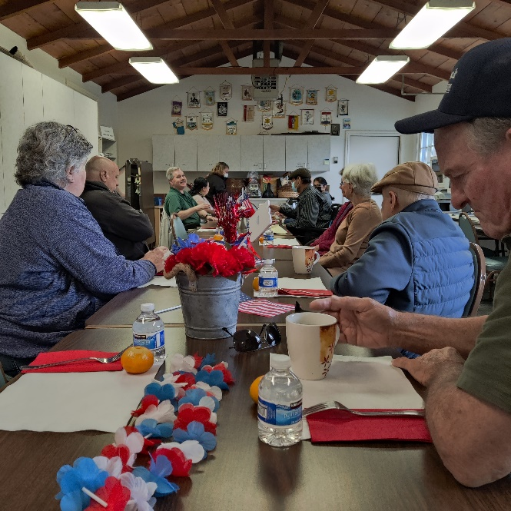
Braille and Ceramic Classes
Braille classes resumed at The Blind and Visually Impaired Center of Monterey County on Tuesday, July 13, 2021 at 10:00 AM. Eight clients attended this session. Anyone interested in attending is urged to call The Blind and Visually Impaired Center at 831-649-3505. Ceramics began on July 20, 2021.

Community Outreach
Community Outreach is a growing service offered by The Blind and Visually Impaired Center of Monterey County. We provide low vision training to service providers, attend health fairs, and present information sessions at senior living centers and in the wider community.
To submit an event invite or demonstration request,
July 6 Support Group
contact Steven Macias, Executive Director, at
831-649-3505.

Contact Us
The Blind and Visually Impaired Center of Monterey County, Inc.
Address: 225 Laurel Avenue, Pacific Grove, California 93950
Telephone: 831-649-3505
Fax: 831-649-4057
Email: vision@blindandlowvision.org
Website: www.blindandlowvision.org
A MESSAGE FROM TOM GARDNER, BOARD PRESIDENT
It’s been a tough year for our clients at The Blind and Visually Impaired Center of Monterey County, but we are excited to announce that we officially welcomed everyone back on Tuesday, July 6, 2021. Clients met face to face for the peer-led support group, which was followed by a Fourth of July luncheon celebration. Braille also began, and both the support group and braille class were well attended. We also welcomed the return of several volunteers and began hosting ceramics again.

Our Executive Director, Steven Macias, is actively pursuing efforts to increase awareness of the Center. On behalf of the Board and myself, I thank him for his efforts.

This August, The Blind and Visually Impaired Center will celebrate 50 years of service in Monterey County. This achievement will be celebrated at our Fall Gala and Silent Auction in November. More information will be sent out next month. We are also gearing up for the mobile low vision clinic and the grand opening of our Salinas office, taking place towards the end of the year.

We look forward to the rest of the year and hope you will join us in supporting and celebrating the Center. None of this would be possible without your support.

Sincerely,
Tom Gardner
Board President

MOBILE LOW VISION CLINIC
With generous funding received from the Harden Foundation, The Blind and Visually Impaired Center of Monterey County is pleased to announce that the mobile low vision clinic will begin this fall, strategically placed at locations through Salinas and South County. This mobile unit will allow The Blind and Visually Impaired Center to be more accessible to clients who would otherwise find it difficult to travel to our Pacific Grove office. While the mobile low vision clinic is not a comprehensive screening, it will allow our Optometrist to identify clients most as risk who need additional follow-up services at our Pacific Grove location.

The mobile low vision unit will be free of charge and exams will be performed on a first-come, first-serve basis. “We see this as a step in the right direction to serve the greater Salinas Valley and to reach those clients who may not be able to reach us” says Steven Macias, Executive Director. “We look forward to establishing a stronger presence in the Salinas Valley and the community at large.”

To schedule your low vision exam at our Pacific Grove office, call The Blind and Visually Impaired Center of Monterey County at 831-649-3505.

A MESSAGE FROM STEVEN MACIAS, EXECUTIVE DIRECTOR
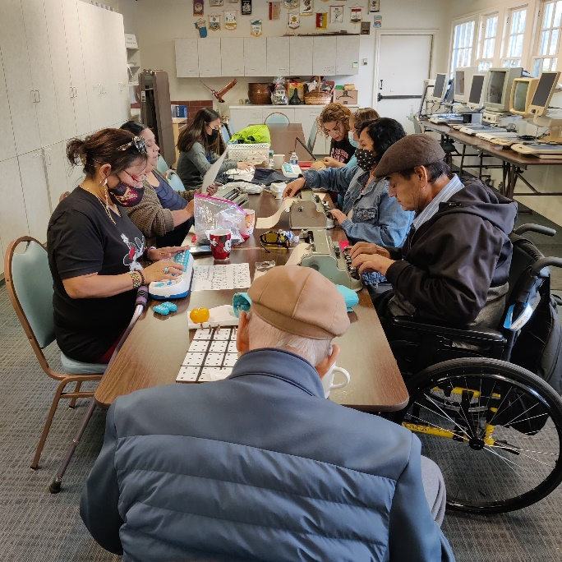
As we celebrate our fiftieth anniversary of The Blind and Visually Impaired Center of Monterey County, much has happened since the Center’s incorporation on August 13, 1971. After almost 16-months since local, State and National Shelter-in-Place Orders were issued, the Board of Directors and I are pleased to welcome back our regular activities at the Center. On July 6, 2021, the peer-led support group and luncheon resumed at our Pacific Grove location. We had 12 members in attendance. Braille classes resumed with eight members in attendance. We are also excited to announce that the mobile low vision clinic will begin this fall and be placed throughout Salinas and South County on a consistent schedule.

Additionally, a separate invitation will be sent out in the coming months inviting everyone to attend our Fall Gala and
July 13 Braille Class
Silent Auction. Details on this event will be sent out at a different time. The event will have an admission cost that will cover Hors D‘oeuvres, dinner and entry to the event. A silent auction and live auction will be available.

We have so much more to do. Your investment in our work will help with many of our programs and expansion efforts.

Thank you for all your support.

Sincerely,
Steven Macias
Executive Director

FALL GALA AND COUNTRY STORE AUCTION
This fall, The Blind and Visually Impaired Center of Monterey County will host a Fall Gala and Silent Auction. Planning is underway and details about the event will be sent out at a later time. The cost per seat will include Hors D’oeuvres, dinner, and entry to the event. Location and keynote speaker to be determined. We look forward to seeing our clients and sponsors at this event that will surely be a memorable evening. This event will also serve as a fundraiser for The Blind and Visually Impaired Center. Sponsorship opportunities are available.

If you would like to discuss ways to donate to the Fall Gala and Silent Auction, or for sponsorship opportunities, contact Steven Macias, Executive Director, at 831-649-3505.
A BRIEF HISTORY OF THE BLIND AND VISUALLY IMPAIRED CENTER OF MONTEREY COUNTY
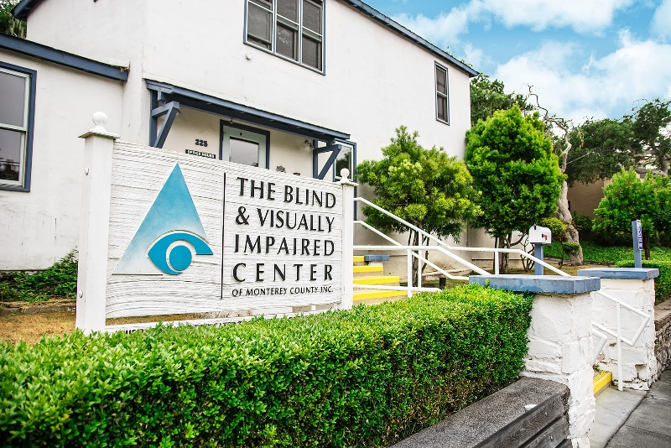
The Blind and Visually Impaired Center of Monterey County, Inc. was formed in 1971 by a small group of concerned citizens led by Ike Soskin. It began as a social, recreational, and educational organization for the blind and visually impaired that met at the local senior center. In 1973, the Center was moved to its current facility at 225 Laurel Avenue in Pacific Grove. The Lions Building for the Blind, a consortium of local Lions Clubs, owns the property and leases it to the Center for one dollar a year.

By 1988, the Center’s vision had grown to include comprehensive rehabilitation services for the visually impaired. The county’s premier low vision clinic was established under the leadership of Cindy Hazard, Kathy Henson and Mike Tomlin. In 2006 the center had a major remodel and the clinic was named the Marjorie R. McNeely Low Vision Clinic.

Currently, the Center offers a complete spectrum of services that help people adapt to the loss of sight. The Board of Directors oversees the policies and direction of the center. To truly reflect the needs of its constituents, more than half of its board members must be visually impaired.

Services are available to Monterey County residents with all levels of vision loss which prevent individuals, even with best corrected vision, from doing everyday tasks independently. This includes those with no light perception, those that have low vision and those who are legally blind. The majority of clients are legally blind or visually impaired. Many eye conditions are age related, therefore most clients are seniors who often have other health challenges.

The age of a client has ranged from as young as a toddler to 104-years old. People of all races, who make up our culturally diverse county, utilize the services. Macular Degeneration remains the most common eye condition, with the majority of those affected falling into the 80+ age group. Diabetic Retinopathy is the most prevalent eye condition among our Hispanic and Latino clients. In addition, Glaucoma and Cataracts are other leading causes of vision loss.

Services are available to county residents regardless of ethnicity, sexual orientation, gender, race or disability. The Blind and Visually Impaired Center is a 501(c)3 non-profit organization that is funded by donations, grants, and fundraisers. Services are free to clients, except for visits with the Optometrist in the Low Vision Clinic.

The Center’s professional specialists work one on one with clients yet have an integrated team approach. Outreach Services are available in a person’s every day surrounding of home, work or other community settings. They are offered without charge on an appointment only basis. Just as there are different levels of visual impairment, the service needs will vary with each individual.
FACE TO FACE WITH RUSSELL HATCH – RETIRED BOARD MEMBER
Steven M.: “Russ, I want to thank you for taking the time to meet with me and go over a few questions regarding the history of the Center. To start, how did you get involved with the Center?”
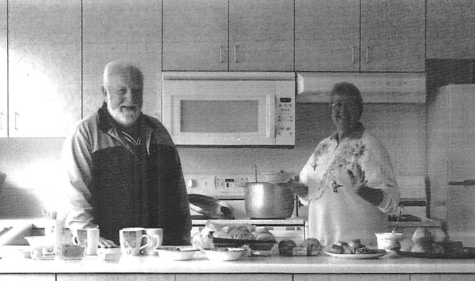
Russ H.: “I was a new member of the Old Capitol Lions Club in 1971, as our club was involved in finding a home for a small group of blind and visually impaired folks who were meeting at the Scholze Center in New Monterey as an “ad hoc” support group. One of our members was a Minister at First Presbyterian in Monterey, Elmer Roy. He had been involved with a blind center in southern California. He and a few others spear-headed the project to find a “home” for the local blind community. We were looking for a small house when we found the building at 225 Laurel Avenue. It had been built as a church in the early 1930’s. A group of about six peninsula Lions Clubs purchased the property from the Odd Fellows fraternal organization in 1971 for $35,000.”

Steven M.: “What were some of the early beginnings and challenges of starting this organization?”

Russ H.: “The Blind Service Center was formed as soon as the building was available. The Board was composed of 7 visually impaired members and 6 sighted members. The initial Executive Directors were all visually impaired, and the visually impaired members formed committees and ran most of the activities. As the Center grew, Orientation and Mobility training was added, and many daily living skills were included in the training with the help of the local State Disabilities Office. The initial challenges revolved around funding to support the activities that were needed in the community.”

Steven M.: “What motivated you to spend so many years at the Center?”

Russ H.: “In 1978 I was asked by Elmer Roy, a founding member, to take his place on the Board. I have been privileged to work with many dedicated people serving with the Blind Center over the years. I served as President and in many other roles, including yard maintenance, several times between 1978 and 2020. As a result of donated vehicles to the Center, I formed the “Chariots for Charity” fundraising program which has raised thousands of dollars over a period of about 25 years and continues today as a part of Old Capitol Lions Club activities. I have received far more from my association with many dedicated and courageous people at the Blind Center than I ever contributed.”

Steven M.: “What direction would you like to see the Center take?”

Russ H.: “The next big step for The Blind and Visually Impaired Center is to expand services into Salinas and South County with a presence, an office, and a mobile unit that can bring services to those who are in need, giving them the opportunity for independence.”
TIMELINE AT THE BLIND AND VISUALLY IMPAIRED CENTER OF MONTEREY COUNTY
1970 – The Reverend Elmer Roy, a member of the Old Capitol Lions Club met with a group of blind and visually impaired individuals who were meeting socially at The Scholze Park Center in New Monterey. It was agreed that this group would benefit from a “home of their own.” The Old Capitol Lions and other area Lions Clubs agreed to form a consortium to purchase a permanent home for the blind and visually impaired in the community.

1971 – The group had been called “Second Sight” and was changed to “The Blind Service Center.” Membership dues were established at $1.00 per member per year.

1972 – The Lions Clubs consortium located and purchased buildings located at 225 Laurel Avenue in. Pacific Grove from the Odd Fellows Fraternal organization for $35,000. A mortgage was created with the Odd Fellows which was paid off in 10 years. The buildings had been built as a church starting in 1929 and was repaired and remodeled to serve the blind and visually impaired by the Lions consortium.

1973 – The Lions Building consortium set up a 20-year lease for the Blind Service Center at $1.00 per year and agreed to provide fire insurance and maintain the exterior of the buildings.

1973 – The first President of the Blind Service Center was Reverend Elmer Roy, a member of Old Capitol Lions Club. The first Director of the Blind Center was Bill Read, a blind member of the Blind Service Center and a member of Old Capitol Lions Club.

1984 – Bill Read retired after 13 years as Director of The Blind Service Center and Kathy Wise (later Kathy Henson) became the Director of The Blind Service Center. Kathy Henson was blind and had been a board member and active member of The Blind Service Center for several years. Cheri Padin was hired as a Secretary for the Center, later to become Bookkeeper.

1988 – The Orientation and Mobility instructor, Cindy Hazard, planned and opened the first Low Vision Clinic with the assistance of Kathy Henson and Dr. Mike Tomlin – the Low Vision Optometrist.

1993 – The second renovation of the buildings was accomplished by The Blind Service Center adding square footage for the creation of three new offices.

1994 – The Blind Service Center name was changed to “The Blind and Visually Impaired Center of Monterey County, Inc.” The Lions Building consortium name had been changed to “The Lions Building for the Blind.”

1997 – Kathy Henson retired as Director of The Blind and Visually Impaired Center. Jeannie Cordero, Kathy’s assistant, and Cheri Padin were appointed as Co-Directors of the Center, Cheri as Business Director and Jeannie as Program Director.

2006 – The third renovation of the Center was accomplished by The Blind and Visually Impaired Center using funds donated to the program. The Low Vision Clinic was redesigned under the direction of the Low Vision Specialist, Moonset Yu and the Low Vision Optometrist, Dr. Andrew Wodecki. The low vision clinic was named after a major donor, Marjorie R. McNeely.

2015 – Jeannie Cordero retired as Co-Director/Program Director. Diana Trapani was hired as the Executive Director of the Center. Rena Weaver, Orientation and Mobility Specialist retired after 25 years of service. Shirley Doolittle retired from the Board and as volunteer after dedicating more than 40 years of service to the Center, Lions and the field of vision loss.

2016 – Dr. Moonset Yu retired after 18 years of service. Dr. Andrew Wodecki moved on after 20 years of service. The Board adopted a new strategic plan.

2017 – Dr. Katie Wendt became the new Low Vision Optometrist

2019 – Diana Trapani moved on as Executive Director after 4 years of service. Dr. Lucy Yen and Dr. Megan Carter are brought in as Low Vision Optometrist.

2020 – Steven Macias is appointed the new Executive Director. Fred Sterenberg replaces Cheri Padin.

2021 – Expansion work is underway to include Salinas based office, mobile low vision clinic, and growth of current programs and services.

SALINAS OFFICE UPDATE
Construction is underway at the Alliance on Aging office at 247 Main Street in Salinas that will allow The Blind and Visually Impaired Center of Monterey County to have a part-time Salinas location. This office will allow the Center to establish a Salinas based support group, as well as allow staff the opportunity to work with clients at this location in addition to our Pacific Grove office. The Salinas office will also serve as a hub for the mobile low vision clinic. Details will become available closer to the opening of this office. The Center expects this new location by the end of the year.

As The Blind and Visually Impaired Center of Monterey County reflects on their fifty years of service, we want to thank all who have helped and supported The Blind and Visually Impaired Center over the years. Your support and work makes all the difference. None of this would be possible without your generous support.

“Alone we can do so little; together we can do so much.”
-Helen Keller

The Blind and Visually Impaired Center
Non-Profit Org
US Postage
PAID
Permit No. 228
Pacific Grove, CA
of Monterey County, Inc.
225 Laurel Avenue
Pacific Grove, California 93950

831-649-3505
vision@blindandlowvision.org

Ways to Donate
You can make a tax-deductible gift online through PayPal at www.blindandlowvision.org/give/ or by mail to: The Blind and Visually Impaired Center of Monterey County, Inc.
225 Laurel Avenue
Pacific Grove, California 93950

Federal Tax ID #23-7221588

Endowment Fund
Did you know that over the years many of our clients and donors have left a bequest to the Center? Their gifts have been used to establish a modest endowment fund. The Board uses earnings from the fund to expand programming, purchase equipment, or supplement the annual operating budget.

Chariots for Charity
Operated by the Monterey Old Capitol Lions Club, Chariots for Charity vehicle donations support The Blind and Visually Impaired Center of Monterey County with cash donations from the sales of donated vehicles. Operated since 1985, the Chariots program has raised more than $350,000 to support the Center.

For more information or to donate a vehicle, contact Russ Hatch at 831-659-5360.

