BLINDFOLD
225 Laurel Avenue, Pacific Grove, California 93950 831-649-3505 www.blindandlowvision.org
Fall 2021

NEWS AND ANNOUNCEMENTS

Peer Support Groups
The support group meets the first and third Tuesdays of each month at 10:00 AM at the Pacific Grove office, located at 225 Laurel Avenue. Ceramics will begin in 2022 on a date to be determined.

The Blind and Visually Impaired Center is also pleased to announce that a Salinas based support group will begin in January at our new office. This Salinas based support group will be held on the second and fourth Tuesdays of each month at 10:00 AM at our office located at 247 Main Street in Oldtown Salinas. The first meeting for the Salinas support group begins on January 11, 2022, at 10:00 AM.

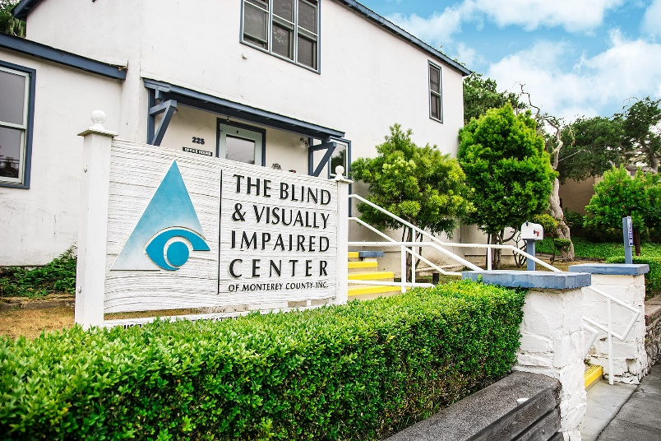
Braille and Ceramic Classes
Braille classes are held the second and fourth Tuesdays of each month at 10:00 AM at the Pacific Grove office, located at 225 Laurel Avenue. Anyone interested in attending is urged to call The Blind and Visually Impaired Center at 831-649-3505.

Community Outreach
Community Outreach is a growing service offered by The Blind and Visually Impaired Center of Monterey County. We provide low vision training to service providers, attend health fairs, and present information sessions at senior living centers and in the wider community. To submit an event invite or demonstration request, contact Steven Macias, Executive Director, at 831-649-3505.

Contact Us
The Blind and Visually Impaired Center of Monterey County, Inc.
Address: 225 Laurel Avenue, Pacific Grove, California 93950
Telephone: 831-649-3505
Fax: 831-649-4057
Email: vision@blindandlowvision.org
Website: www.blindandlowvision.org
A MESSAGE FROM TOM GARDNER, BOARD PRESIDENT
In 2020, The Blind and Visually Impaired Center, like many other small nonprofits, was largely impacted because of COVID. For most of 2020 and the start of 2021, the office remained closed to group meetings and supports groups were held through Zoom. So far, 2021 has been a more eventful year. In May of this year, Dr. Wendt returned to her regular position as our lead Optometrist. We began hosting in-person supports groups and luncheons in July, Jenny Swad became our new Orientation and Mobility Specialist in October, and we are preparing to open our Salinas office.

We are also happy to announce that The Blind and Visually Impaired Center is once again participating in Monterey County Gives!, which serves as the major fundraiser. I encourage everyone to give generously this year. Your contribution enables our staff to continue their good work in the community in serving those with visual impairments with the education and skills training they need to live independent lives. This year, The Blind and Visually Impaired Center has impacted several hundred clients.

Our impactful work is not possible without your generous support. On behalf of the Board of Directors and I, we wish everyone a safe and healthy holiday season and thank you for your support.

Sincerely,
Tom Gardner
Board President

SALINAS OFFICE AT 247 MAIN STREET IN OLDTOWN SALINAS
This January, The Blind and Visually Impaired Center of Monterey County will open its door to the Salinas office located at 247 Main Street in Oldtown Salinas. This office, staffed on Tuesdays and Thursdays only, allows clients to participate in support groups, receive a basic eye evaluation as part of our mobile low vision clinic, and receive and learn about the services The Blind and Visually Impaired Center offers, as well as other senior services available on the Monterey Peninsula.

The Salinas based support group will begin holding meetings in January on the second and fourth Tuesdays of the month at this location at 10:00 AM. The first support group is scheduled for Tuesday, January 11, 2022, at 10:00 AM. The Salinas office will also feature a small café with food for purchase, computers for training purposes, one-on-one cooking classes and daily life skills training.

“We’re excited to see our Center progressively expanding into Salinas and the Salinas Valley,” says Steven Macias, Executive Director. “Having this office will allow us to better connect with clients who live in the greater Salinas area and provide them with more immediate services.”

To learn more about the Salinas office, call The Blind and Visually Impaired Center of Monterey County at 831-649-3505.
A MESSAGE FROM STEVEN MACIAS, EXECUTIVE DIRECTOR
I want to thank everyone for contributing to The Blind and Visually Impaired Center this year. Your contributions, whether through financial means, volunteering, promotion of the Center through word of mouth, or other means, allows us to continue to serve the clients of Monterey County.

This year marked many milestones for the Center. In May, we welcomed back Dr. Wendt to her position as our Optometrist. In July, we hosted in-person support groups, after a year of meetings through Zoom. In August, we celebrated our fiftieth anniversary. In October, we hired Jenny Swad as our full-time Orientation and Mobility Specialist and held our White Cane Day. In November we once again began participating in Monterey County GIVES! And in January, we plan to open our Salinas office, with support groups being held at this location the second and fourth Tuesdays of the month beginning January 11, 2022.

These plans can only become possible with your generous support. Please, give generously this year. Your gift has the ability to change someone’s life. I can be reached at 831-649-3505 or by email at steven@blindandlowvision.org to discuss how your support makes all the difference.

I wish everyone a safe and happy holiday season.

Sincerely,
Steven Macias
Executive Director

DID YOU KNOW? - AMAZON SMILE
Did you know you could shop Amazon AND support The Blind and Visually Impaired Center of Monterey County at the same time?

Through smile.amazon.com, 0.5% of you Amazon Smile purchase goes directly to The Blind and Visually Impaired Center. To get started, visit smile.amazon.com, type in “The Blind and Visually Impaired Center of Monterey County,” and select it as your nonprofit. Then shop.

FALL GALA AND SILENT AUCTION
Due to COVID-19 concerns, The Blind and Visually Impaired Center of Monterey County postponed The Fall Gala and Silent Auction until 2022. We look forward to seeing you in attendance next year.

If you would like to discuss ways to donate to the Fall Gala and Silent Auction, or for sponsorship opportunities, contact Steven Macias, Executive Director, at 831-649-3505.
MONTEREY COUNTY GIVES! – NOVEMBER 11 THROUGH DECEMBER 31
On Thursday, November 11, the Monterey County Gives! campaign officially began, with The Blind and Visually Impaired Center of Monterey County once again participating in this vital fundraising endeavor. This crucial campaign runs until December 31, 2021 and greatly benefits the Center. Last year we raised $30,028.87. With your help, we can continue our mission to serve and empower our clients toward an independent life through education, support services and skills training. This campaign serves as one of the major sources of funding for The Blind and Visually Impaired Center, the only public low vision clinic in Monterey County.

In 2000, the Weekly supported the nonprofit community when it established the Monterey County Weekly Community Fund, a donor advised fund of the Community Foundation for Monterey County. In 2009, Monterey County Gives! was launched, focused on an annual appeal to the Weekly’s generous readers for year-end donations. In that first year, $417,000 was raised and granted. The Weekly has built on that success each year, and with the Monterey Peninsula Foundation joining as a partner in 2015, the campaign has shown the power of philanthropy in Monterey County.

To donate online, please visit www.montereycountygives.com/blind to make your donation. You can also mail a check directly to:

Community Foundation for Monterey County
Attn: MCGives!
2354 Garden Road
Monterey, California 93940

Checks MUST be made payable to “Community Foundation for Monterey County” (or “CFMC”, or “CFMC/MCGives”). Please remember to include your full name, address, and in the memo section of the check write “Blind and Visually Impaired Center” (or “BVIC”).

Alternatively, you can send your check to The Blind and Visually Impaired Center and we will send it to The Community Foundation for Monterey County.

The Blind and Visually Impaired Center of Monterey County encourages everyone to give generously this year to allow us to continue to serve and empower our clients toward an independent life through education, support services and skills training. Your contribution has the ability to greatly impact someone’s life. Give generously.

DID YOU KNOW? – VISION LOSS
Did you know 63% of adults are unaware that you do not always experience symptoms before you lose vision to eye disease.
Source: American Academy of Ophthalmology
RETURNING ORIENTATION AND MOBILITY SPECIALIST JENNY SWAD
The Blind and Visually Impaired Center of Monterey County welcomes back Jenny Swad as our Orientation and Mobility Specialist. Jenny has a wide array of knowledge and skills in Orientation and Mobility as well as Low Vision Therapy.

Jenny Swad began her career working for the Palo Alto Veteran’s Administration as the Orientation and Mobility Specialist. After six years, she became the Low Vision Specialist and eventually the Blind Rehabilitation Specialist and Outpatient Specialist. After over twenty years with the Palo Alto Veteran’s Administration, she was hired on as the Low Vision Service Coordinator for The Blind and Visually Impaired Center of Monterey County. Having served in her role here for several years, she left to work for Central Coast Senior Services. The Blind and Visually Impaired Center welcomed her back in October 2021. Jenny has a Bachelors in Special Education, Visual Impairment form Eastern Michigan University, and a Masters degree in Orientation and Mobility from Western Michigan University.

To schedule your visit with our Orientation and Mobility Specialist, call The Blind and Visually Impaired Center of Monterey County at 831-649-3505.

WHITE CANE DAY
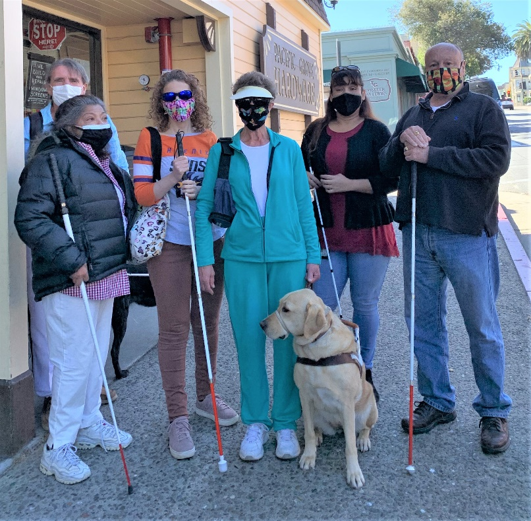
Friday, October 15, 2021, marked White Cane Day. Clients, staff, volunteers, and friends came together to bring awareness to the community. The white cane stands as a symbol of opportunity and community recognition, and The Blind and Visually Impaired Center is proud to be a part in supporting the independence of those with vision loss.

Ken Hunter, past president and board member for The Blind and Visually Impaired Center, led the group throughout Pacific Grove where they visited with merchants and enjoyed a lunch at Victorian Corner Restaurant following the excursion.

To learn more about White Cane Day and participating in next year’s event, contact The Blind
and Visually Impaired Center at 831-649-3505.
MONTEREY-SALINAS TRANSIT TRAVEL TRAINING PROGRAM
Monterey-Salinas Transit (MST) offers free fixed-route travel training to teach interested individuals, groups, and organizations how to ride the bus safely and independently.

Buses and transit centers are thoroughly cleaned each night using hospital grade disinfectants, and hand-held foggers are used to spray germicide inside buses to decontaminate the coach. Hand sanitizer dispensers have been installed on all buses to help keep passenger hands clean, windows are kept open to allow air inside buses to be refreshed quickly, and visual reminders have been placed throughout the bus asking everyone to maintain a safe distance from other passengers.

After training, you will discover how easy it is to plan a trip; understand route maps, stops, schedules and landmarks; get to and from bus stops safely; get on and off the bus safely; pay fares and purchase passes; ride a specific route; transfer to other buses; and if needed, use a mobility device when riding.

Not only are passengers gaining independence, but they are also saving money, enjoying the opportunity to meet other passengers, making a positive impact on the environment, and gaining valuable time to relax while leaving the driving to MST.

Contact the MST Mobility Services Center to schedule your training at 831-264-5886.

STAFF UNIFORMS
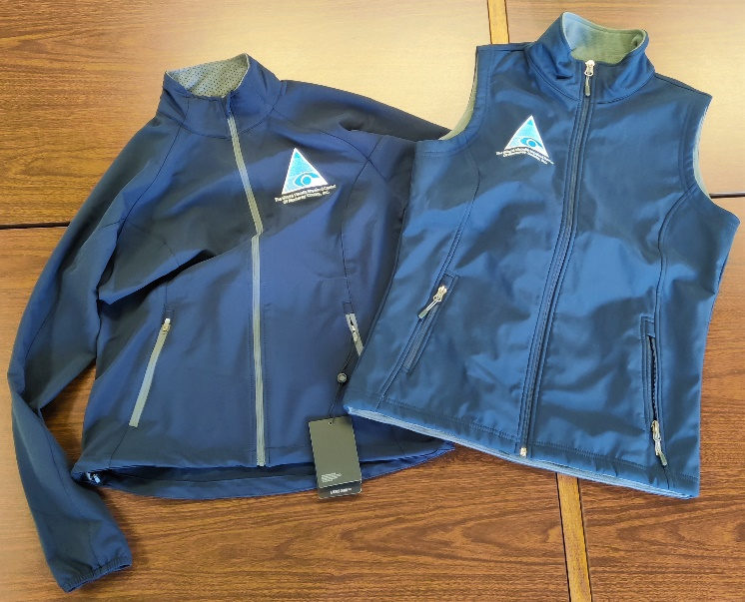
The Blind and Visually Impaired Center of Monterey County would like to thank the Rotary Club of Carmel for their generous contribution to allow the Center to purchase jackets and vests for all staff members. A portion of the grant will also be used to revitalize the garden to create a sensory setting for clients to enjoy.

“We deeply appreciate the Rotary Club of Carmel for providing this grant,” says Steven Macias, Executive Director. “These uniforms will give us greater visibility and presence in the community. Each time staff, including myself, put on these jackets, we feel a great sense of pride in the work we do.”

HAPPY HOLIDAYS FROM THE BLIND AND VISUALLY IMPAIRED CENTER
The Blind and Visually Impaired Center of Monterey wants to wish everyone a happy and safe holiday season. As a reminder, our Pacific Grove office will be closed starting on Monday, December 20, 2021 and re-open on January 3, 2022. If you need services during that timeframe, please call us at 831-649-3505 and we will return your call as soon as possible.

The Blind and Visually Impaired Center of Monterey County would like thank Manitou Fund and the McNeely family for their generosity in supporting our work. Their ongoing contributions have allowed us to provide services to hundreds of residents of Monterey County and provide the essential education, skills training, and services to help these individuals lead an independent life.

“Alone we can do so little; together we can do so much.”
-Helen Keller

BOARD MEMBERS AND VOLUNTEERS
The Blind and Visually Impaired Center of Monterey County is proud to recognize their current board members and volunteers:

Board of Directors

- Tom Gardner, President
- Dr. Celia Barberena, Vice-President
- Alissa Whittle, Treasurer
- Sonja Jackson, Secretary
- Dr. Gary Gray
- Randy Henson
- Toula Hubbard
- Dr. Ken Hunter
- Bob Johnson

Staff

- Steven Macias, Executive Director
- Martha Burgoon, Blind Rehabilitation Specialist/Low Vision Clinic Coordinator
- Megan Carter, OD, Low Vision Optometrist
- Karen Levin, Vision Rehabilitation Specialist
- Fred Sterenberg, Finance and Compliance Coordinator
- Jenny Swad, Orientation and Mobility Specialist
- Marisa Vallejo, Intake Assistant/Receptionist
- Katie Wendt, OD, Low Vision Optometrist

Volunteers

- Cora Derbin
- Reem Fayyad
- Bailey Shioya

The Blind and Visually Impaired Center
Non-Profit Org
US Postage
PAID
Permit No. 228
Pacific Grove, CA
of Monterey County, Inc.
225 Laurel Avenue
Pacific Grove, California 93950

831-649-3505
vision@blindandlowvision.org

Ways to Donate
You can make a tax-deductible gift online through PayPal at www.blindandlowvision.org/give/ or by mail to: The Blind and Visually Impaired Center of Monterey County, Inc.
225 Laurel Avenue
Pacific Grove, California 93950

Federal Tax ID #23-7221588

Endowment Fund
Did you know that over the years many of our clients and donors have left a bequest to the Center? Their gifts have been used to establish a modest endowment fund. The Board uses earnings from the fund to expand programming, purchase equipment, or supplement the annual operating budget.

Chariots for Charity
Operated by the Monterey Old Capitol Lions Club, Chariots for Charity vehicle donations support The Blind and Visually Impaired Center of Monterey County with cash donations from the sales of donated vehicles. Operated since 1985, the Chariots program has raised more than $350,000 to support the Center.

For more information or to donate a vehicle, contact Russ Hatch at 831-659-5360.

