BLINDFOLD
225 Laurel Avenue, Pacific Grove, California 93950 831-649-3505 www.blindandlowvision.org
Spring 2022

NEWS AND ANNOUNCEMENTS

Peer Support Groups

Pacific Grove Peer Support Group: First and third Tuesdays of each month at 10:00 AM at 225 Laurel Avenue in Pacific Grove.
Salinas Peer Support Group: Second and fourth Thursdays of each month at 10:00 AM at 236 Monterey Street in Salinas.

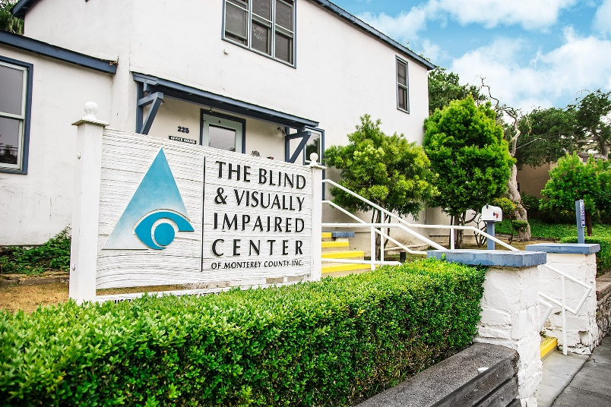
Braille Classes
Pacific Grove Braille Class: Second Tuesday of each month at 10:00 AM at 225 Laurel Avenue in Pacific Grove.

Salinas Braille Class: Fourth Tuesday of each month at 10:00 AM at 236 Monterey Street in Salinas starting May 24, 2022.

Anyone interested in attending is urged to call The Blind and Visually Impaired Center at 831-649-3505.

Community Outreach
Community Outreach is a growing service offered by The Blind and Visually Impaired Center of Monterey County. We provide low vision training to service providers, attend health fairs, and present information sessions at senior living centers and in the wider community. To submit an event invite or demonstration request, contact Steven Macias, Executive Director, at 831-649-3505.

Contact Us
The Blind and Visually Impaired Center of Monterey County, Inc.
Address: 225 Laurel Avenue, Pacific Grove, California 93950
Telephone: 831-649-3505
Fax: 831-649-4057
Email: vision@blindandlowvision.org
Website: www.blindandlowvision.org
A MESSAGE FROM TOM GARDNER, BOARD PRESIDENT
This is an exciting time for The Blind and Visually Impaired Center of Monterey County. We have a new staff member, Randy Hyatt, we have officially opened our Salinas office location, and through generous funding from Manitou Fund and The McNeely Family we are able to renovate the interior of our Pacific Grove office.

As we continue to host support groups in Pacific Grove on Tuesdays, we are now offering support groups in Salinas on Thursdays. We will soon be offering braille in Salinas starting May 24, 2022. We are also working on the development of our Fall Gala and Silent Auction and mobile clinic set to start at the end of the year. This will allow us to target clients in underserved communities in Salinas and South County.

Our impactful work is not possible without your generous support. On behalf of the Board of Directors and I, we thank you for your support.

Sincerely,
Tom Gardner
Board President

BLIND AND VISUALLY IMPAIRED CENTER RAISES $32,738.30 THROUGH MONTEREY COUNTY GIVES!
On behalf of the Board of Directors, staff and especially the clients of The Blind and Visually Impaired Center of Monterey County, I am writing to thank to you for your generous donations made through the Monterey County Gives! annual campaign. This year, the Center received $32,738.30, the most raised in the Center’s history since our participation in this fundraising event. Even with the hardships of the pandemic occurring, you still generously donated. For that, we extend our sincerest appreciation. Your contribution will continue to allow us to provide services at little to no cost to residents throughout Monterey County who are living with vision loss.

I send my best wishes and, again, thank you for your support through Monterey County Gives!

Steven Macias
Executive Director
SALINAS OFFICE AT 236 MONTEREY STREET IN OLDTOWN SALINAS
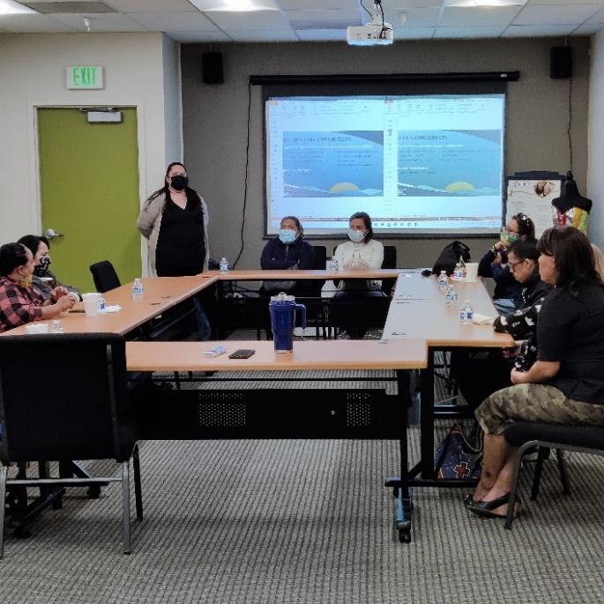
On January 4, 2022, The Blind and Visually Impaired Center of Monterey County opened its door to the Salinas office located at 236 Monterey Street in Oldtown Salinas. This office, staffed on Tuesdays and Thursdays, allows clients to participate in support groups, attend braille classes, receive individual cooking instruction, and learn about the services The Blind and Visually Impaired Center offers, as well as other senior services available on the Monterey Peninsula.

The Salinas based support group meets every second and fourth Thursdays of the month at 10:00 AM. Coffee and a light breakfast are provided at no charge.
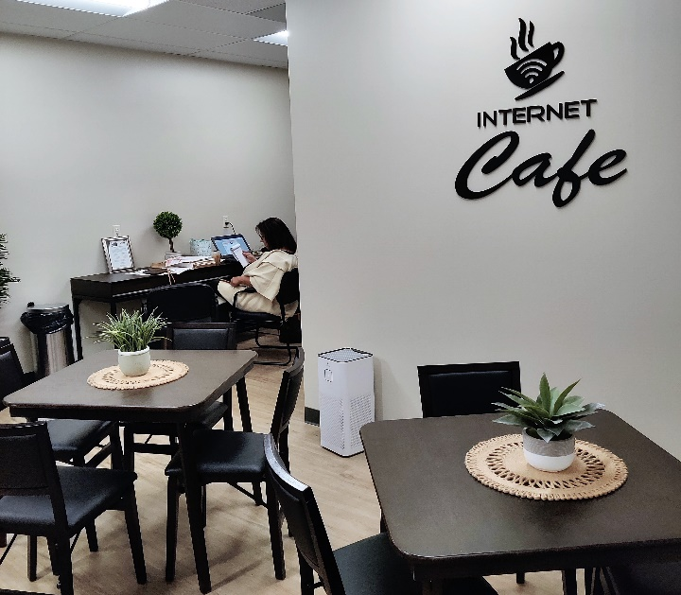

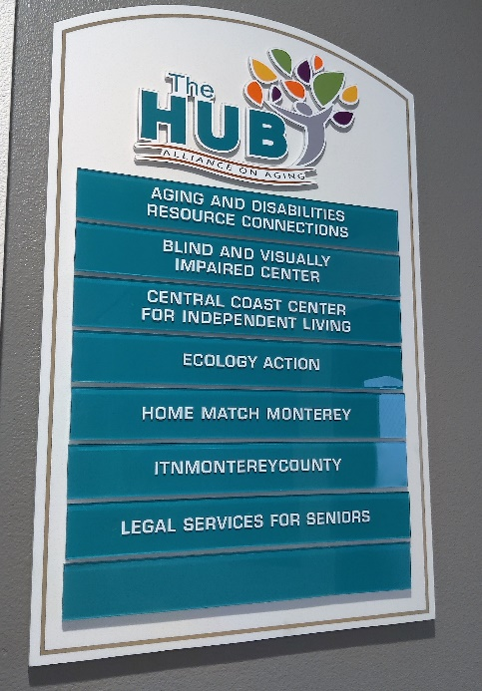
“We’re pleased to announce that construction is complete and our doors our finally opened” says Steven Macias, Executive Director. “The Board and I are proud to make this dream a reality by expanding into Salinas. With this prime location, we can better serve clients in the surrounding communities of Salinas and South County.”

The Salinas office, as part of Alliance on Aging’s HUB Project, features multi-use conference rooms, an internet café, and snacks available for purchase. Alliance on Aging also features senior related events at this location.

To learn more about the Salinas office, call The Blind and Visually Impaired Center of Monterey County at 831-649-3505.

AMAZON SMILE
Did you know you could shop Amazon AND support The Blind and Visually Impaired Center of Monterey County at the same time?

Through smile.amazon.com, 0.5% of you Amazon Smile purchase goes directly to The Blind and Visually Impaired Center. To get started, visit smile.amazon.com, type in “The Blind and Visually Impaired Center of Monterey County,” and select it as your nonprofit. Then shop.
A MESSAGE FROM STEVEN MACIAS, EXECUTIVE DIRECTOR
A lot has transpired at The Blind and Visually Impaired Center of Monterey County since our last newsletter. The Center officially opened its doors at our new Salinas location at 236 Monterey Street, we hired a new staff member, received several large grants courtesy of Monterey County Gives!, the Harden Foundation, and Manitou Fund and The McNeely Family, and are currently undergoing an entire interior renovation at our Pacific Grove office.

As we look towards the future, we plan to continue our outreach into Salinas and South County and plan to start the mobile low vision clinic later this year. Plans are also underway to host our Fall Gala and Silent Auction on November 13, 2022.

These plans can only become possible with your generous support. Please, give generously this year. Your gift can change someone’s life. I can be reached at 831-649-3505 or by email at steven@blindandlowvision.org to discuss how your support makes all the difference.

Sincerely,
Steven Macias
Executive Director

2022-2023 SLATE OF OFFICERS AND BOARD MEMBERS
The Blind and Visually Impaired Center of Monterey County is pleased to announce the 2022-2023 slate of Officers and Board Members. These individuals guide the Center towards its mission and vision.

- Tom Gardner, President
- Dr. Celia Barberena, Vice-President
- Alissa Whittle, Treasurer
- Sonja Jackson, Secretary
- Dr. Gary Gray
- Randy Henson
- Toula Hubbard
- Dr. Ken Hunter
- Bob Johnson

FALL GALA AND SILENT AUCTION
Plans are underway for The Blind and Visually Impaired Center of Monterey County’s Fall Gala and Silent Auction. The tentative date is November 13, 2022, at the Monterey Marriott Ferrantes Bay View Room. Invited Keynote Speaker is Representative Jimmy Panetta (D-Carmel Valley) and our confirmed Master of Ceremonies will be Salinas Mayor Kimbley Craig. Tickets will be $150 per person and includes a three-course meal, wine, and entertainment. We look forward to seeing you at this premier event.

If you would like to discuss ways to donate to the Fall Gala and Silent Auction, or for sponsorship opportunities, contact Steven Macias, Executive Director, at 831-649-3505.
CENTER RECEIVES $50,000 TWO-YEAR HARDEN FOUNDATION GRANT
The Blind and Visually Impaired Center of Monterey County received a two-year, $50,000 grant from the Harden Foundation to be used towards the development and staffing of our new Salinas office.

“We deeply appreciated the support of the Harden Foundation for all they do in the community and with our Center,” says Steven Macias, Executive Director. “Without their contribution to our vital efforts, our Salinas office may not have come to fruition.”

The grant also went towards funding our new staff member, Randy Hyatt. The Blind and Visually Impaired Center is pleased to welcome him onboard at our Pacific Grove office on Tuesdays and Thursdays.

LABELING AND ORGANIZING HOUSEHOLD ITEMS
Everyone has their own unique way of labeling a product or item. Labelling makes the items easier to locate and identify. It prevents confusion from items that are not labeled.

When labelling and organizing household items, one should consider some of these questions before beginning.
1. Should the labeling system be permanent?
2. Can the labels be reused?
3. Is the material durable to withstand laundering or daily use?
4. How will the labels be attached to the item?

Some of the more effective labelling systems The Blind and Visually Impaired Center finds useful are:
- Unruled 3x5 index cards
- Colored electrical tape
- Wide tip markers
- Laundry markers
- Fabric paint
- Velcro
- Rubber bands
- Metal labels
- Pipe cleaners
- Foam letters
- Identi-Buttons Clothing Identifiers
- Bump dots, and
- PenFriend
CENTER RECEIVES $75,000 MANITOU FUND AND MCNEELY FAMILY GRANT
The Blind and Visually Impaired Center of Monterey County would like thank Manitou Fund and The McNeely Family for their generosity in supporting our work. Their ongoing contributions have allowed us to provide services to hundreds of residents of Monterey County and provide the essential education, skills training, and services to help these individuals lead an independent life.
Recently, Manitou Fund and The McNeely Family provided a generous grant in the amount of $75,000 for the interior renovation of the Pacific Grove office. “This grant will allow us to completely renovate the interior of our office,” says Steven Macias, Executive Director. “We will have new furniture, new paint, a redone waiting room all with high quality product throughout the entire office. We deeply appreciate this funding.” Work is scheduled to be completed in June.
The Board of Directors thank Mr. McNeely for his generous contributions to this effort.

MONTEREY-SALINAS TRANSIT TRAVEL TRAINING PROGRAM
Monterey-Salinas Transit (MST) offers free fixed-route travel training to teach interested individuals, groups, and organizations how to ride the bus safely and independently.

Buses and transit centers are thoroughly cleaned each night using hospital grade disinfectants, and hand-held foggers are used to spray germicide inside buses to decontaminate the coach. Hand sanitizer dispensers have been installed on all buses to help keep passenger hands clean, windows are kept open to allow air inside buses to be refreshed quickly, and visual reminders have been placed throughout the bus asking everyone to maintain a safe distance from other passengers.

After training, you will discover how easy it is to plan a trip; understand route maps, stops, schedules and landmarks; get to and from bus stops safely; get on and off the bus safely; pay fares and purchase passes; ride a specific route; transfer to other buses; and if needed, use a mobility device when riding.

Not only are passengers gaining independence, but they are also saving money, enjoying the opportunity to meet other passengers, making a positive impact on the environment, and gaining valuable time to relax while leaving the driving to MST.

Contact the MST Mobility Services Center to schedule your training at 831-264-5886.

BOARD MEMBER SEARCH
The Blind and Visually Impaired Center of Monterey County is actively seeking Board Members for one-year terms. This volunteer Board meets six times per year at our Pacific Grove office and guides the Center towards its mission of empowering the blind and visually impaired toward independent living through education, support services and skills training.

To express your interest, please contact Steven Macias, Executive Director at 831-649-3505 or by email at steven@blindandlowvision.org.
SIGHTED GUIDE OVERVIEW
There are many types of vision loss and visual functioning. Most people who are legally blind have some useful vision which can be different with each person. Some people can see various things such as light, contrast, and blurry shapes. Some people can see better if it is cloudy, or in the daylight. Some people cannot see uneven surfaces or steps; some can see far ahead but cannot see nearby objects or steps without extreme head turning.

Sighted guide is practical for any visually impaired or blind person at times. Ask your visually impaired companion, “Would you like to take my arm?” Using a sighted guide instead of a long cane or dog-guide is a matter of personal preference. At times someone carrying a cane or using a dog-guide also will use a sighted guide.
Offer your arm to the person. The person should grab your arm just above the elbow. Do not grab the person’s arm or try to push or pull the person. Stay half a step ahead of the person you are guiding so that he or she will have time to stop when you stop.

Pause at the top of steps or a curb. Allow the person to feel the edge of the first step with his foot and grab a rail with a free hand. Stay one step ahead of the person to provide warning of the last step.

To go through narrow spaces, ask the person to step behind you, still holding your arm. Check that he or she is squarely behind you.

When going through doorways, switch arms if necessary to allow the person to help to keep the door open as he or she follows you. If you are holding a door open, tell the person you are doing so.

If you are closing a car door, tell the person you are about to close the door. This prevents accidents of someone reaching for the door handle at the same time it is being closed.

Do not grab a blind person by the elbow or shoulder and steer him or her ahead of you.

To show a person the location of the back of a chair ask, “May I put your hand on the chair?” Be prepared for the person to either consent or to say, “No, just tell me when the chair is in front of me.”

If you are unsure if a visually impaired or blind person needs help, just ask. He or she may just be in the process of figuring something out or listening to traffic cues. Respectfully saying “would you like some information or are you okay?” is an acceptable approach.

To learn more about sighted guide techniques, contact The Blind and Visually Impaired Center of Monterey County at 831-649-3505.

The Blind and Visually Impaired Center
Non-Profit Org
US Postage
PAID
Permit No. 228
Pacific Grove, CA
of Monterey County, Inc.
225 Laurel Avenue
Pacific Grove, California 93950

831-649-3505
vision@blindandlowvision.org

Ways to Donate
You can make a tax-deductible gift online through PayPal at www.blindandlowvision.org/give/ or by mail to: The Blind and Visually Impaired Center of Monterey County, Inc.
225 Laurel Avenue
Pacific Grove, California 93950

Federal Tax ID #23-7221588

Endowment Fund
Did you know that over the years many of our clients and donors have left a bequest to the Center? Their gifts have been used to establish a modest endowment fund. The Board uses earnings from the fund to expand programming, purchase equipment, or supplement the annual operating budget.

Chariots for Charity
Operated by the Monterey Old Capitol Lions Club, Chariots for Charity vehicle donations support The Blind and Visually Impaired Center of Monterey County with cash donations from the sales of donated vehicles. Operated since 1985, the Chariots program has raised more than $400,000 to support the Center.

For more information or to donate a vehicle, contact Russ Hatch at 831-659-5360.

